High Demand UBER AreasReport



Sepideh Berangi (S3793021)

Mohammad Farshidmehr (S3308107)  
24th May 2020

### Contribution Agreement

# **High Demand UBER Areas**

**ParsGroup**

|  |  |
| --- | --- |
| Student Name: Sepideh Berangi | Student Name: Mohammad Farshidmehr |
| Student ID: S3793021 | Student ID: S3308107 |
| Contributions:  Sepideh Berangi 50% | Contributions:  Mohammad Farshidmehr 50% |
| Contribution Percentage: 50% | Contribution Percentage: 50% |
| *By signing below, I certify all information is true and correct to the best of my knowledge.*    Signature: Sepideh Berangi    Date: 17 May 2020 | *By signing below, I certify all information is true and correct to the best of my knowledge.*    Signature: Mohammad Farshidmehr    Date: 17 May 2020 |

### Link

Our project is an android application which shows the data analysis on the uber dataset based on the MapReduce procedure performed on the Kmeans Clustering algorithm in AWS. The generated report of the data analysis (done by BigQueryGeoViz, BigQuery, and RScript) will appear in a PHP webpage as charts and mpas in the link provided below:

<http://100.27.13.191>

### Summary

With our mobile app, the clients will be able to access their current location information or any specific part of the map. The map will display the demand rate of user requests based on the data provided by UBER. This information could be useful for UBER to identify the location of busy areas, for profiting more in their business. In addition, this data will be useful for the local government's traffic governance and the police to check the traffic flow of certain areas in order to improve their services.

### Introduction

It’s vital for every sort of business to identify the highly requested areas in order to perform better and be able to plan for their future. Businesses, Police, and Government would want to know where are the most visited and crowded locations in the city to be able to enhance their services.

In this application, we have aimed to identify the busy and high demand areas based on the data provided by UBER. Firstly, our application could help companies and people who are keen to open a new business such as restaurants, insurance companies, banks, etc., and secondly, it could give some important information to the local police. From the location and crowd flow, the police can provide the necessary equipment and security force, to insure the security of the area. Finally, the local government can leverage this information to improve the current infrastructure of the city to do construction in targeted and demanding locations.

This application requires information that is published by the UBER company which is the greatest limitation of our process due to the fact that UBER will release its own customer data, every three to five years. The suggestion to resolve this issue is to sign a contract with UBER under their own policies that these data will only be used in this application. This solution requires loads of expenses. However, the application works fine at the moment (working with the data already provided by UBER) and could be installed by a lot of people who may want to know the UBER data analysis.

The information provided in our app, could be very useful in real life because the analysed information of the locations would be vital for the police, government, people, and businesses. People would be motivated to use this application by enough advertisement, to access better visual, and more accurate analysis of the data.

### Related work

**The Traveltime website [1]** is one of the websites that gives information to the user, based on three factors: PostCode, Map, and travel time. The results analysed and shown to the users, explain about time duration of an employee to arrive at their workplace. It gives good information but is not useful for people who want to open a business or improve their business.

### Software design/architecture

This application is working in two parts:

1. Android mobile application
2. AWS services and Google Cloud Data Analysis tools.

* Android mobile application side (Client Side)

The services that are using in the mobile application side are

* Cloud tools for Android
* Cloud mobile app
* Cloud API
* Firebase Authentication
* Firebase Cloud storage
* Firebase Cloud Message and notification
* Google Maps API
* Google Maps GPS
* App Analytics
* EC2 (Apache Server for hosting)
* Data Analytic Services (AWS)
* AWS services and Google Cloud Data Analysis tools (Server Side)
  + Services used to generate the clusters in AWS:
    - JAVA
    - AWS-EMR
    - EC2
    - IAM
    - AES-S3 Bucket
    - VPC Subnet
  + Services used for analysing the output data in Google Cloud Platform:
    - BigQuery
    - SQL
    - R
    - Google Cloud Compute Engine
    - GeoViz
    - Data studio

Android mobile Application side (Client Side)

## 

Points database structure:

The database name is locations and it has 6 documents. Each document has a record with 3 string fields. (Count, Longitude, Latitude) for keeping the location and count to keep the number of samples.

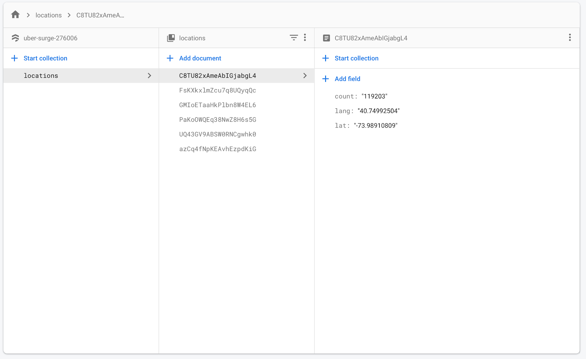

Authentication database:

Which is the default Firebase data structure. Each record contains: Identifier, Providers, Created, Signed In, and User UID, for keeping the user information.

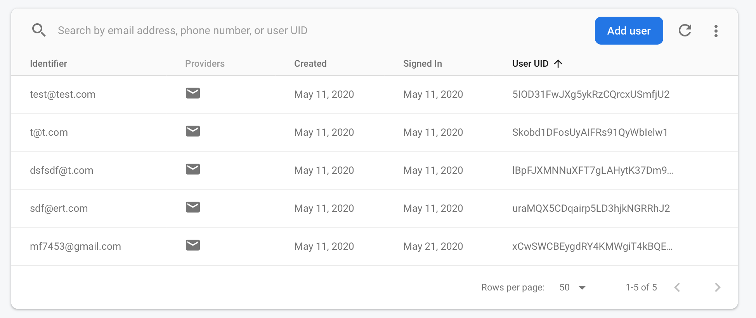

### Implementation

### Mobile Application Client Side

Developer Manual: A step-by-step guideline to reproduce your project [use figure if required] and make it live. This is like our tutorial sheet. For known/general description (e.g. creating a MySQL RDS instance in AWS, deploying the project in Elastic Beanstalk, deploying the project in Google cloud) you can refer to any web link directly. You can also refer to the tutorial sheet if you have similar steps in your description (e.g. deploy the application in Google cloud).

**Note: Google account**

This implementation is a working for users who have google cloud accounts. If anyone does not have any google cloud account they can create one. More information is available in this link: <https://cloud.google.com/> and you can select Get started for free.

1. Login to google account to see the Google Cloud Platform dashboard.

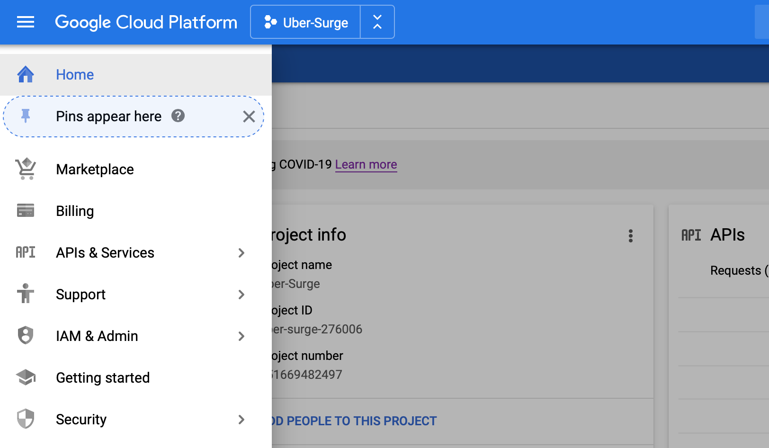

* 1. If there are any projects already created, select one and If no projects exist, create a new one by clicking on the project name. A window like the figure below will appear. You can follow the link to create a new project.

<https://cloud.google.com/appengine/docs/standard/nodejs/building-app/creating-project>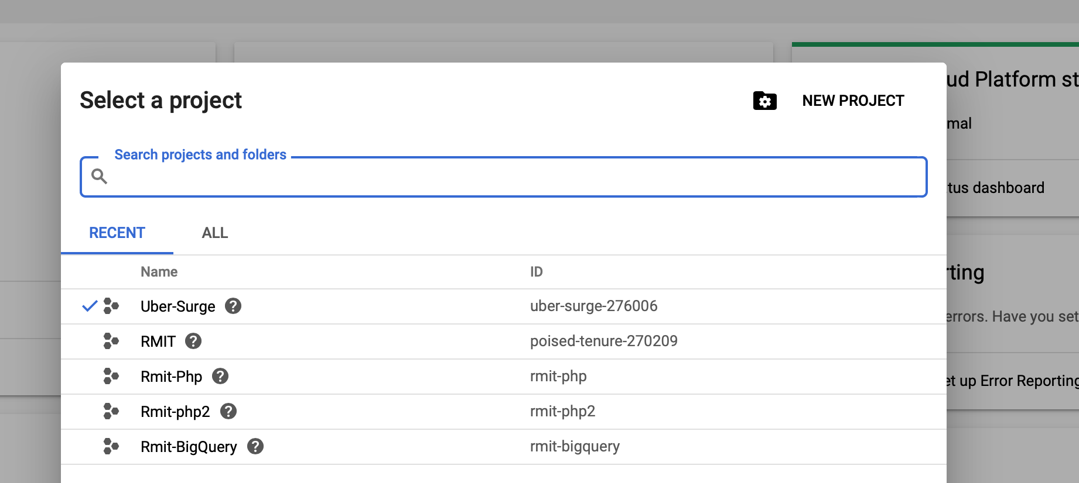

1. Create a Mobile Application
   1. Create a Firebase project

Go to <https://firebase.google.com> and then select Get Started or select Go to console. If any projects exist there, you can select one. If no projects exist, you can create one by following 4 easy steps that are demonstrated below:

* + 1. Press add project



* + 1. Select a name

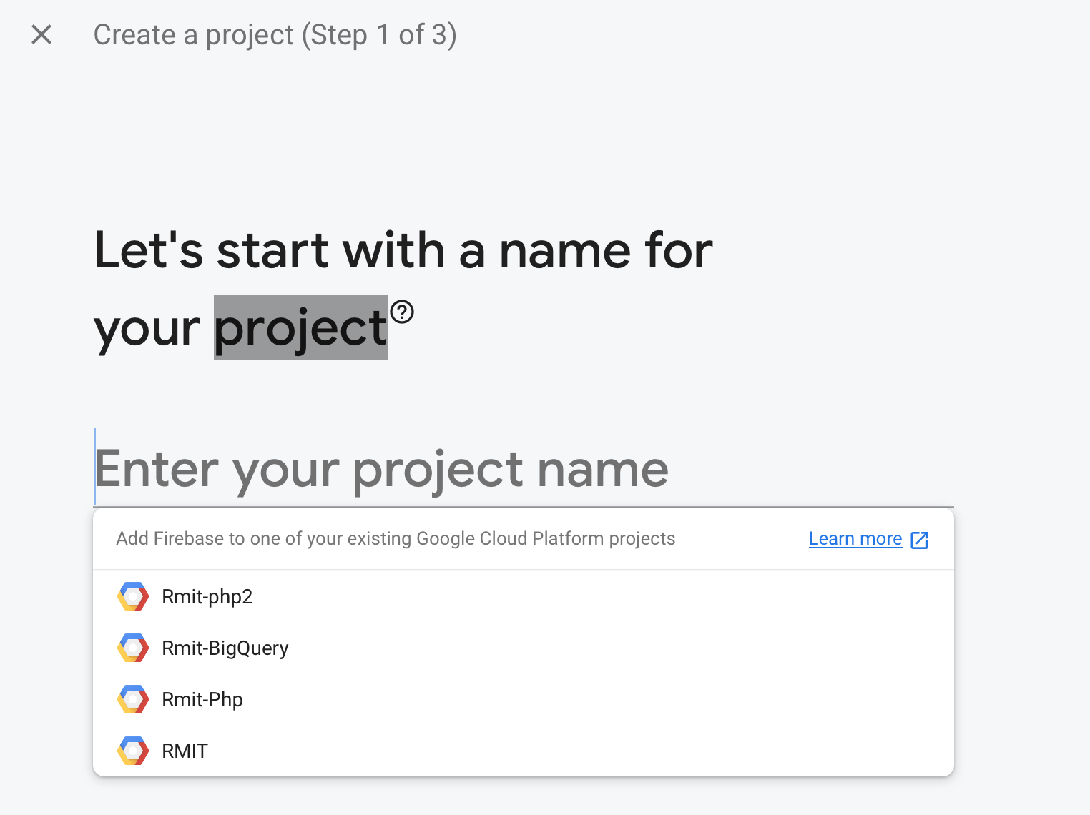

* + 1. Select Continue

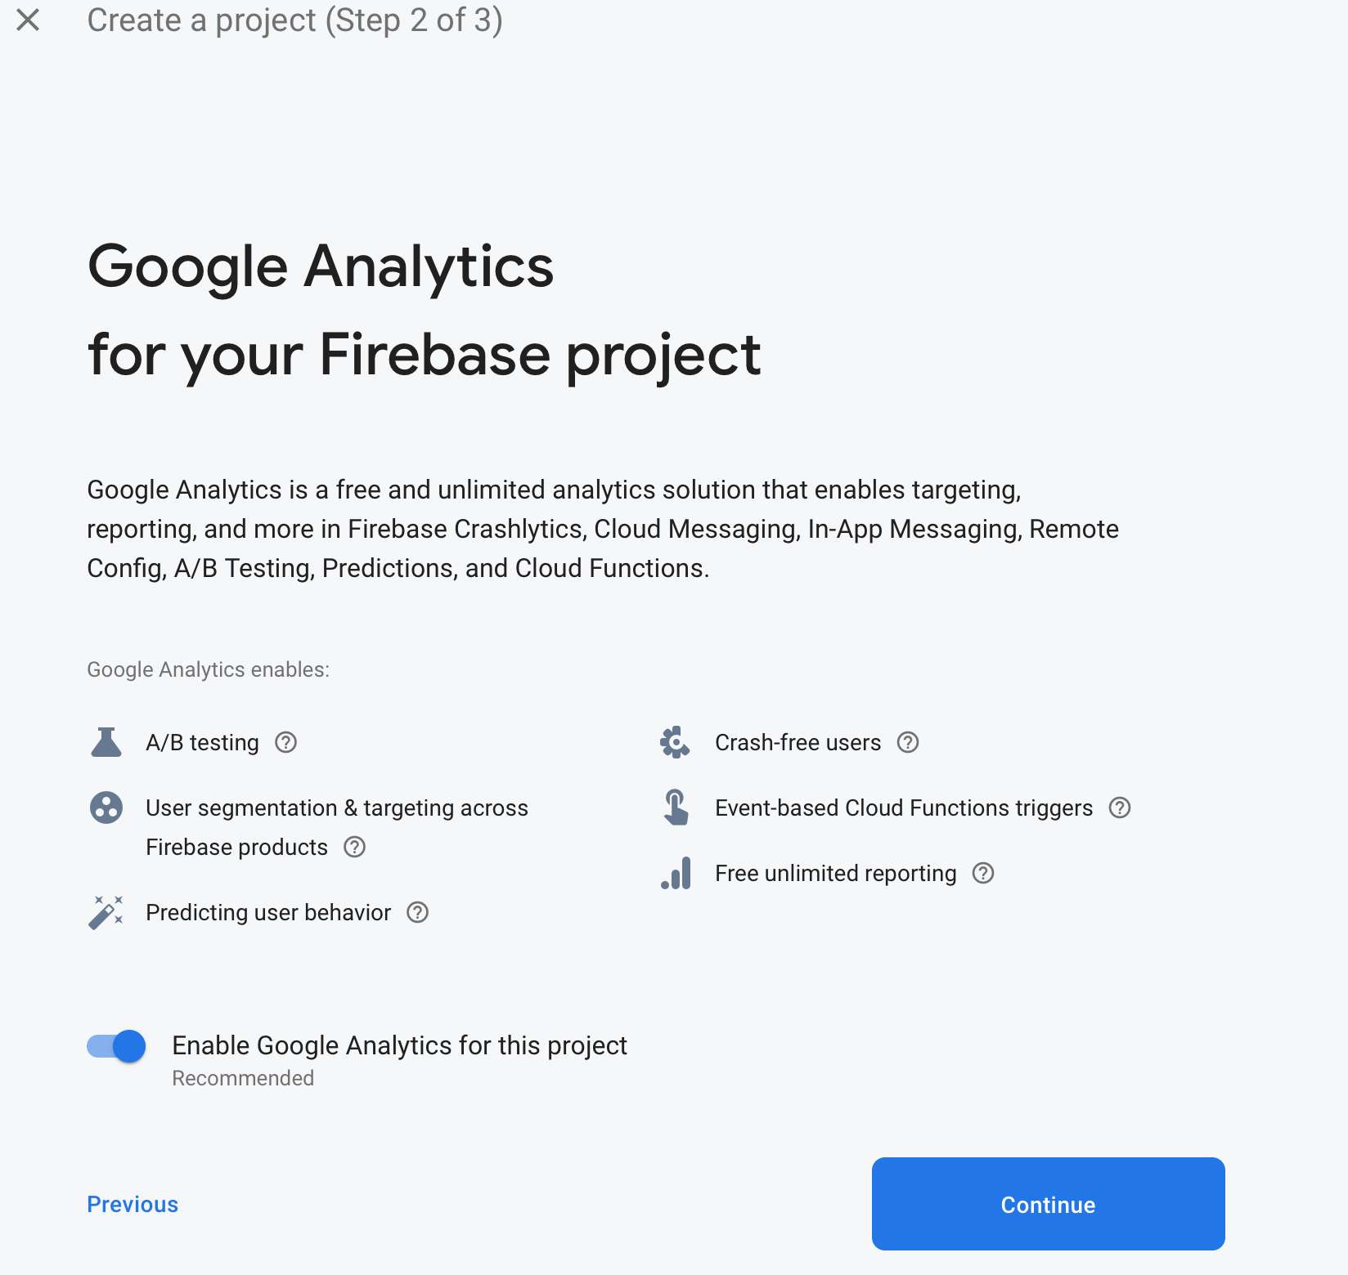

* + 1. Select Analytic account and then press Create Project

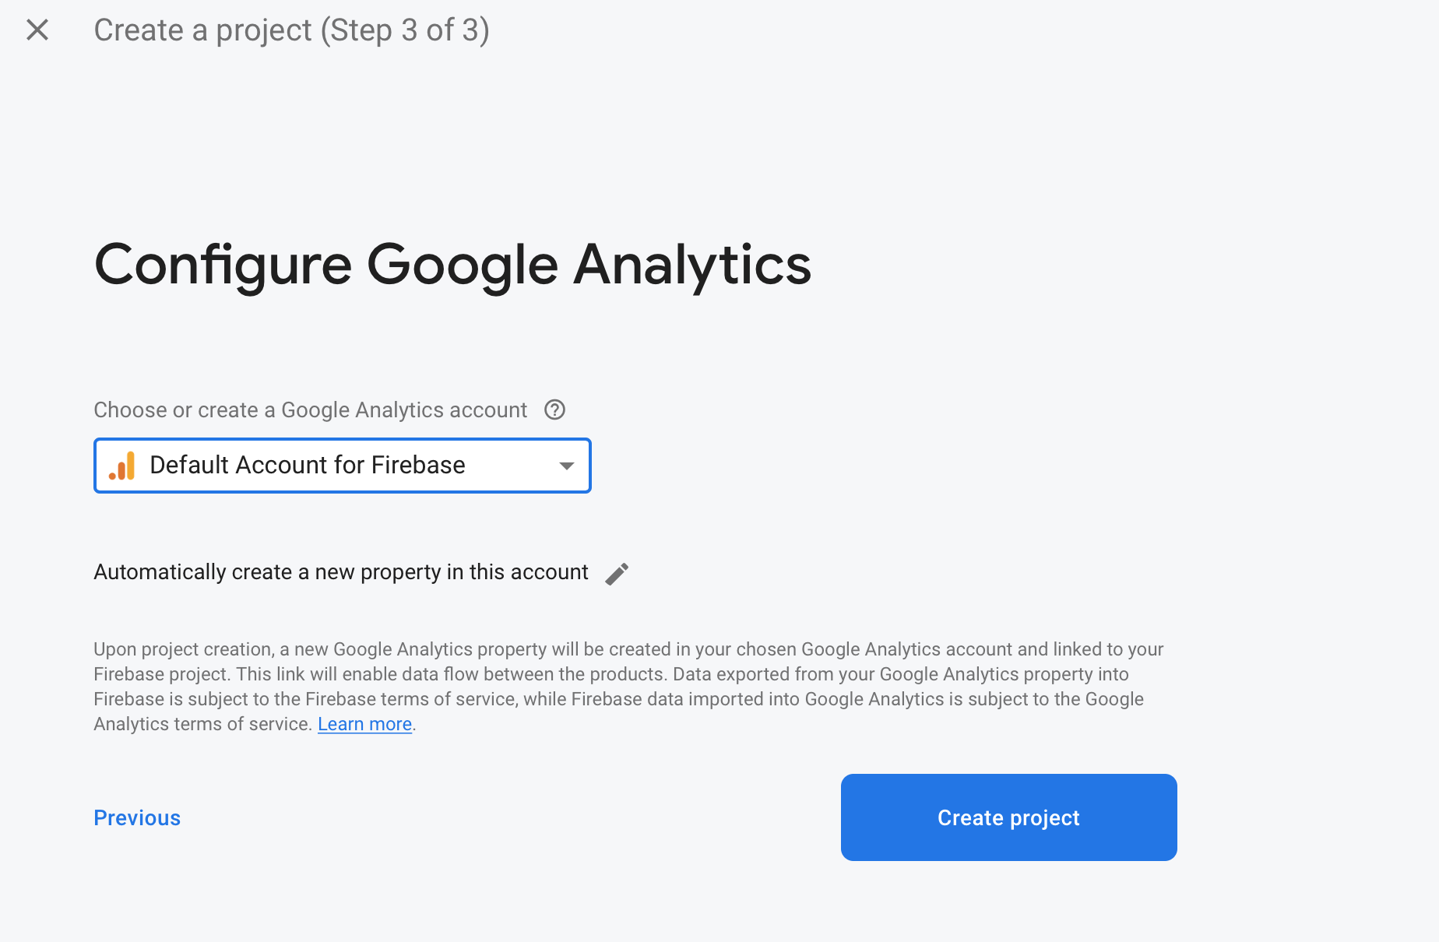

* 1. Add app into Firebase project

If there are any appa available, you can select one or otherwise you can follow the steps to create a new app:

* + 1. Select Add app



* + 1. Select your platform such as android,ios



* + 1. Give a name and follow wizards to create an app. For more information you can follow the link below:

<https://cloud.google.com/solutions/mobile/mobile-firebase-app-engine-flexible>

**Make sure to download the config file and save it in the right place.**

1. Install and config Android studio

For creating an android mobile application follow the link below: <https://developer.android.com/studio/>

1. Create an Android Application

Follow the below links steps to create a new application in Android Studio:

<https://developer.android.com/training/basics/firstapp/creating-project>

**Copy the configuration file to the app folder in Android Studio**

1. Adding Firebase Authentication UI

Firebase Authentication UI is prepared as an authentication feature for each app that can log in to the apps. It gives an option to the user that can create SSO to each mobile application such as (Login by phone number, Gmail, Email, Facebook, Tweeter, Github and Linkedin). The link below can explain how you can create user authentication for mobile apps:

<https://firebase.google.com/docs?authuser=0>

1. Cloud Storage

For saving data to the database and reading and writing to the database in the mobile application, we can use Cloud Storage in firebase for apps. For creating a database and accessing it from a mobile app follow the links below:

<https://firebase.google.com/docs/stora>

<https://firebase.google.com/docs/firestore/query-data/get-data>

<https://firebase.google.com/docs/storage/android/start>

1. Cloud Messaging

When a mobile app or application is developed, it is necessary to inform users some important information and keep them updated. For example, the version of an application that will deploy or any other information such as new material or any information that will be prepared and generated by an application that is crucial to their users. For adding these features to your application please follow the below link:

<https://firebase.google.com/docs/cloud-messaging/android/first-message>

1. Maps

The best feature for each mobile application is a map. Google has developed a strong map API feature for clients. Maps can show the current location of mobile devices. They can give useful information to the users such as: address, hotels, restaurants, directions from current location to a specific destination, define home and workplace and so on. Prior to using Google maps, you need to enable Google Map API by following the link below:

<https://support.google.com/googleapi/answer/6158841?hl=en>

After enabling the Google Map API you can use the maps and its features in the mobile application. For using the maps please follow the below links:

<https://console.cloud.google.com/google/maps-apis/overview?project=uber-surge-276006&folder=&organizationId=>

<https://developers.google.com/maps/documentation/android-sdk/start?hl=en_US>

<https://developers.google.com/maps/documentation/android-sdk/map?hl=en_US>

<https://developers.google.com/maps/documentation/android-sdk/location?hl=en_US>

1. Google Analytics

Google Analytics is a web analytics service offered by Google that tracks and reports website traffic, currently as a platform inside the Google Marketing Platform brand. Google launched the service in November 2005 after acquiring Urchin. For adding and configuring the Analytics feature please follow the steps:

<https://support.google.com/analytics/answer/1008015?hl=en>

### AWS map Data Analyse (Server Side)

The diagram below, shows how the java program interacts with the s3 bucket and the emr cluster, and how the EMR cluster interacts with EC2 and IAM service:

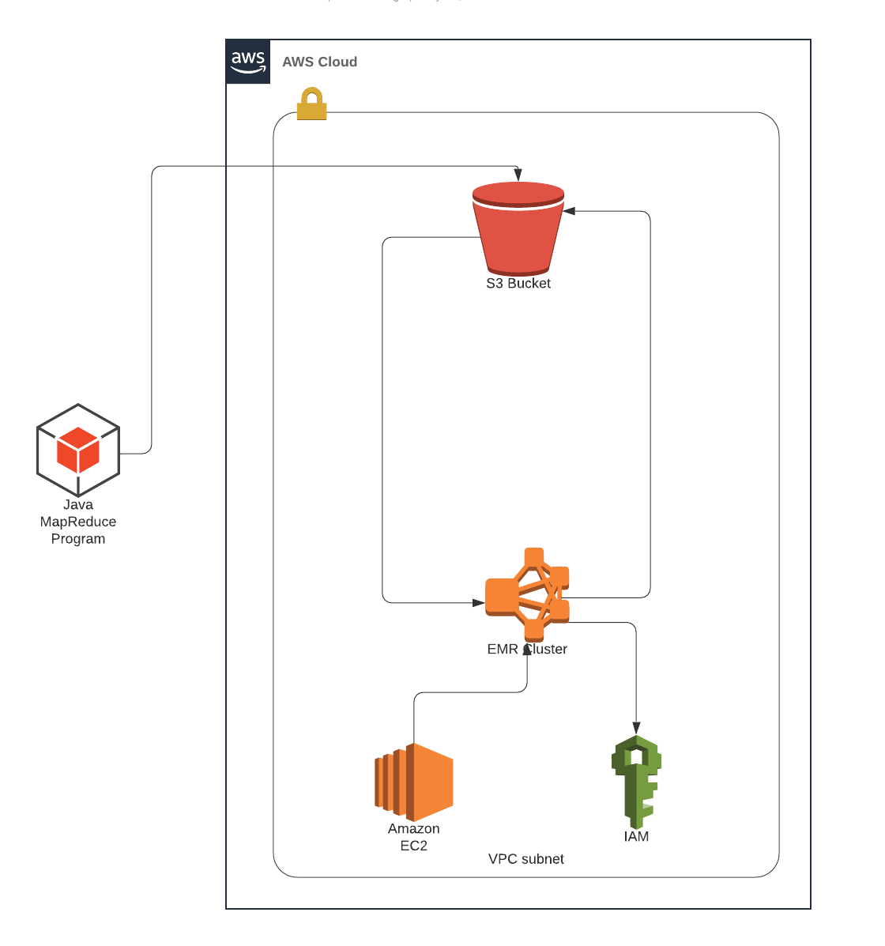

### K-Means MapReduce

We have performed MapReduce on the K-means clustering algorithm to be able to process our large scale data in order to identify the high-demand areas. The original dataset was about 1GB which we reduced it to 22MBs and cleaned the data to be able to process it easier and visualize the results on the map more clearly. We used 6 centroids at the beginning of the MapReduce task, and by running the program, these 6 centroids will be converged to a fixed value, at the end. The Map gets a centroid and a data point, then measures the distance between them and assigns the nearest data point to each centroid and outputs a key-value pair of centroid and its associated data point. The Reducer class gets a centroid and iterable centroids as inputs, recomputes the new centroid’s position and updates the centroid. This procedure continues till all the centroids are merged and the values and clusters are fixed. Then the Job class reads a file from our s3 bucket and initiates the centroids with values, close to the real data point values which are hard coded in the program. At the end, after certain amounts of iterations, the output of all the iterations are written into a file named ”output.txt” in the output folder of our s3 bucket which results in the final clusters. Above we have shown how our program interacts with the EMR and the s3 bucket. We upload our final .JAR file on the s3 bucket, and then create a cluster in EMR as shown below:

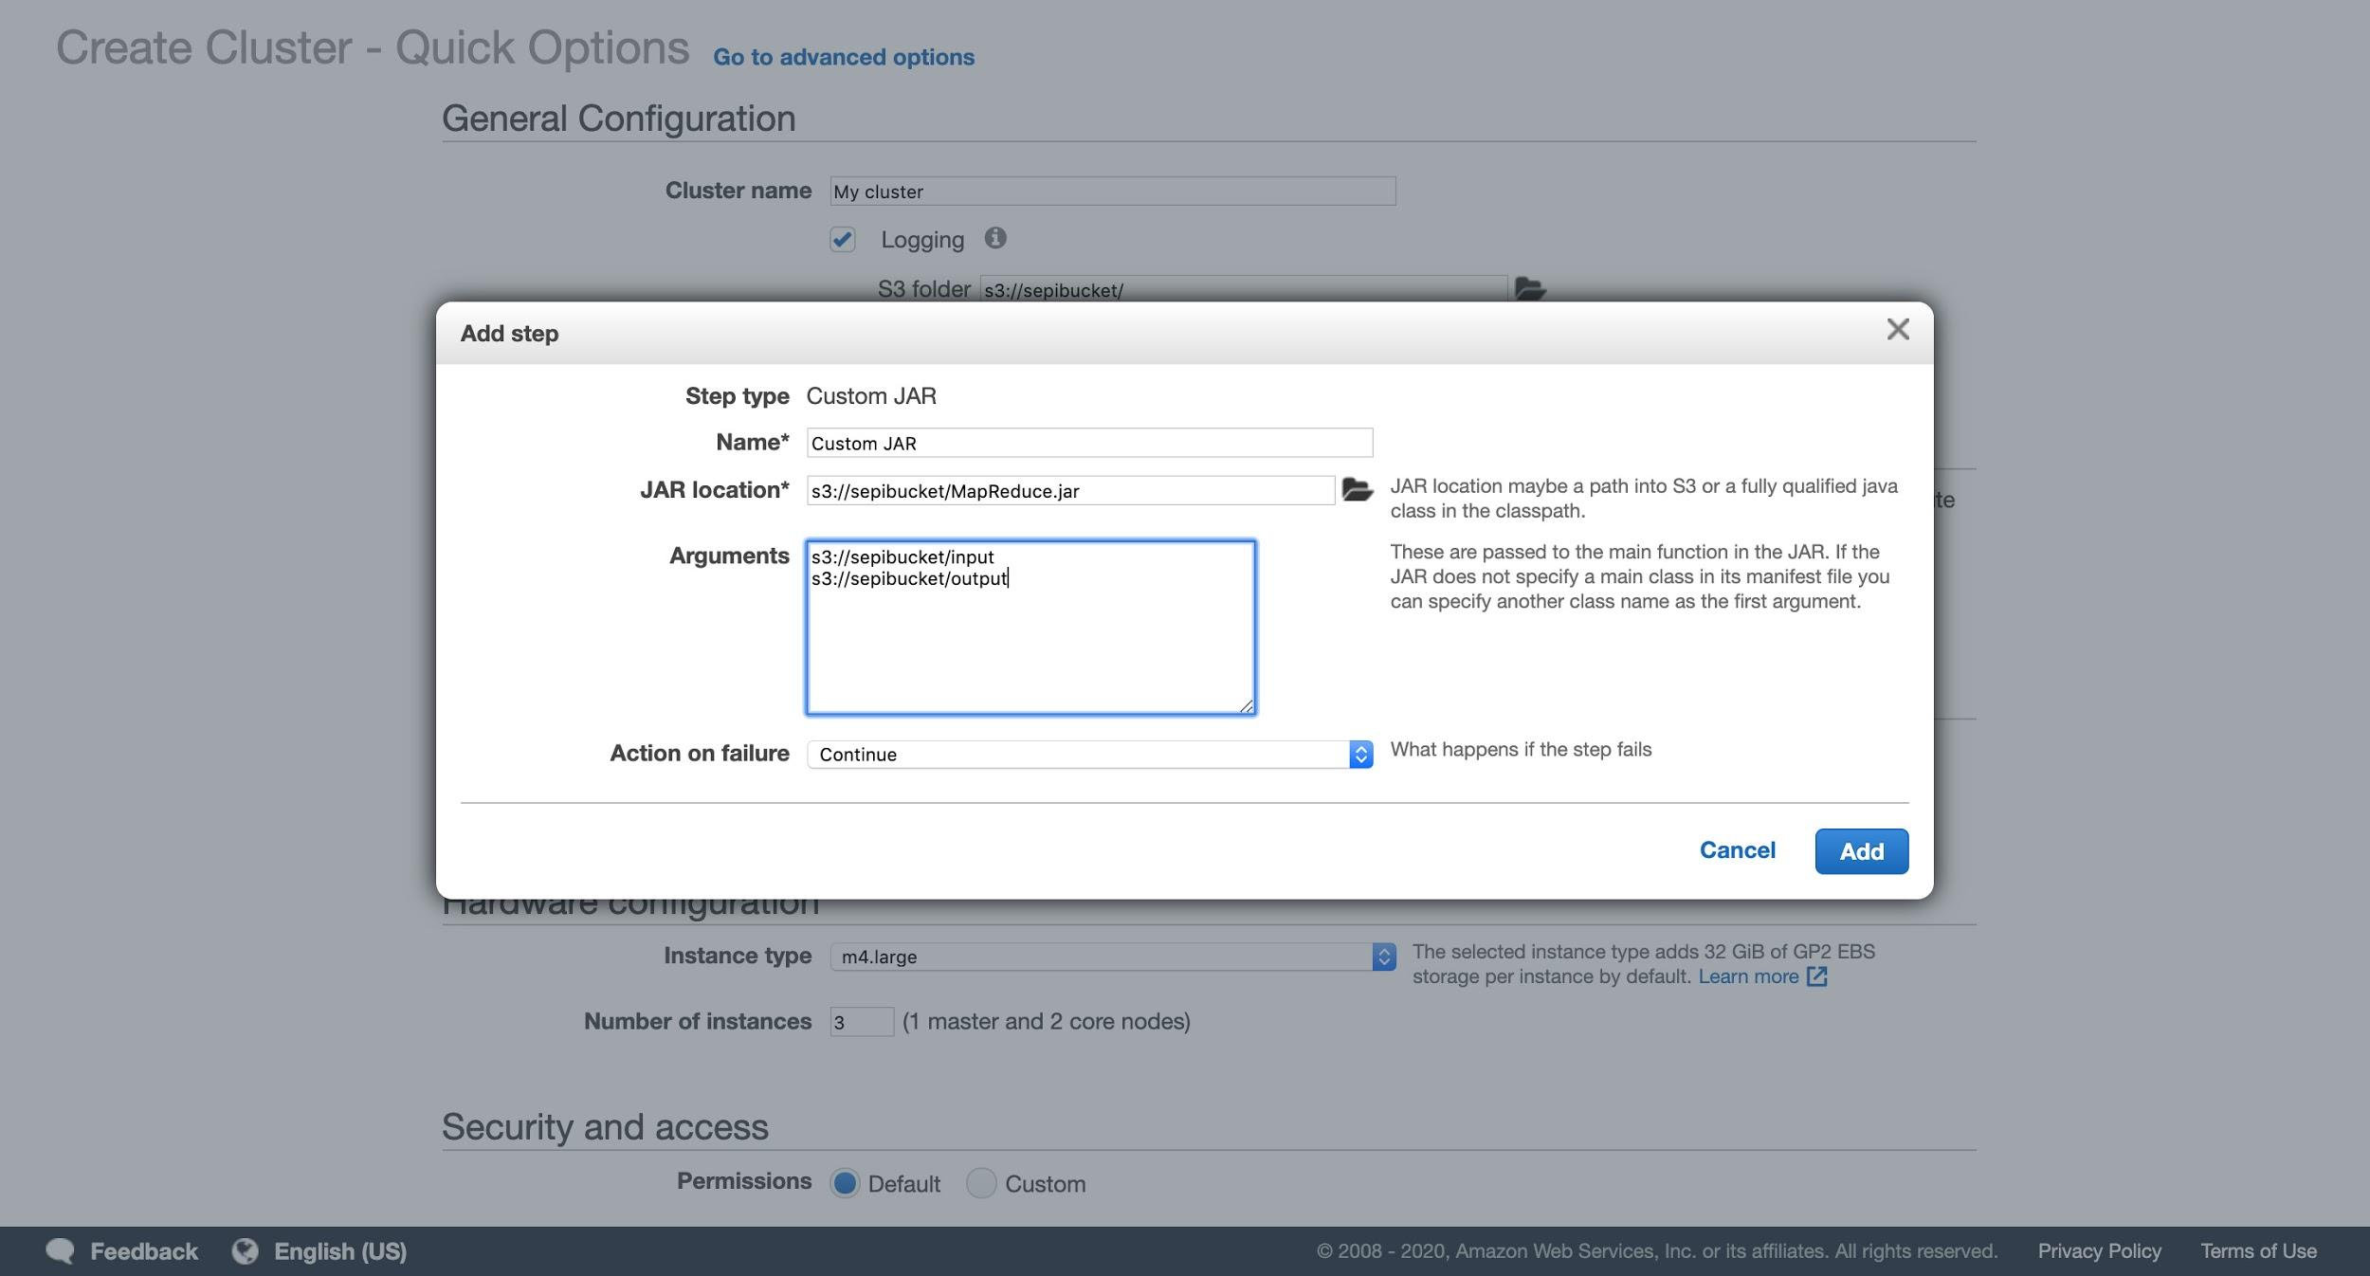

Then click on create cluster and wait for the program to be executed:

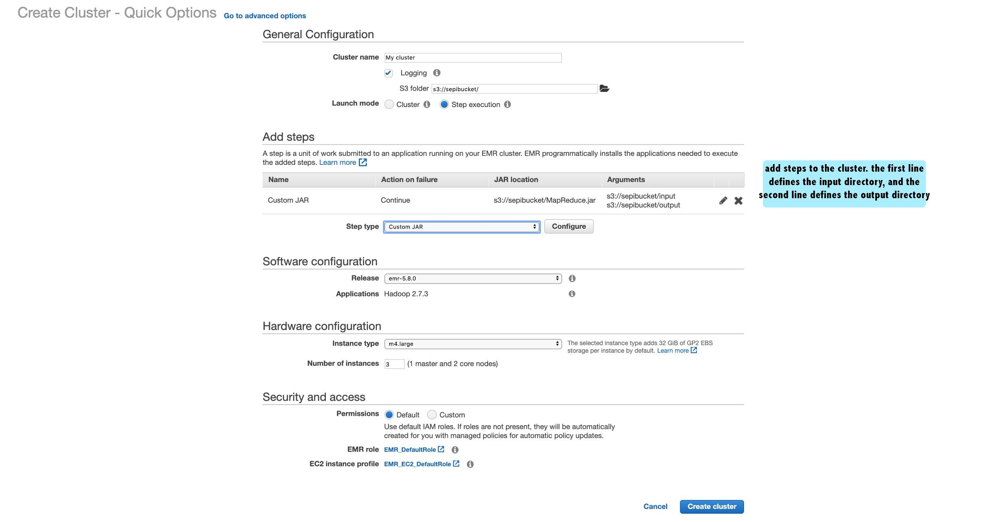

When the cluster starts, it will show the Running status while it’s performing the steps:

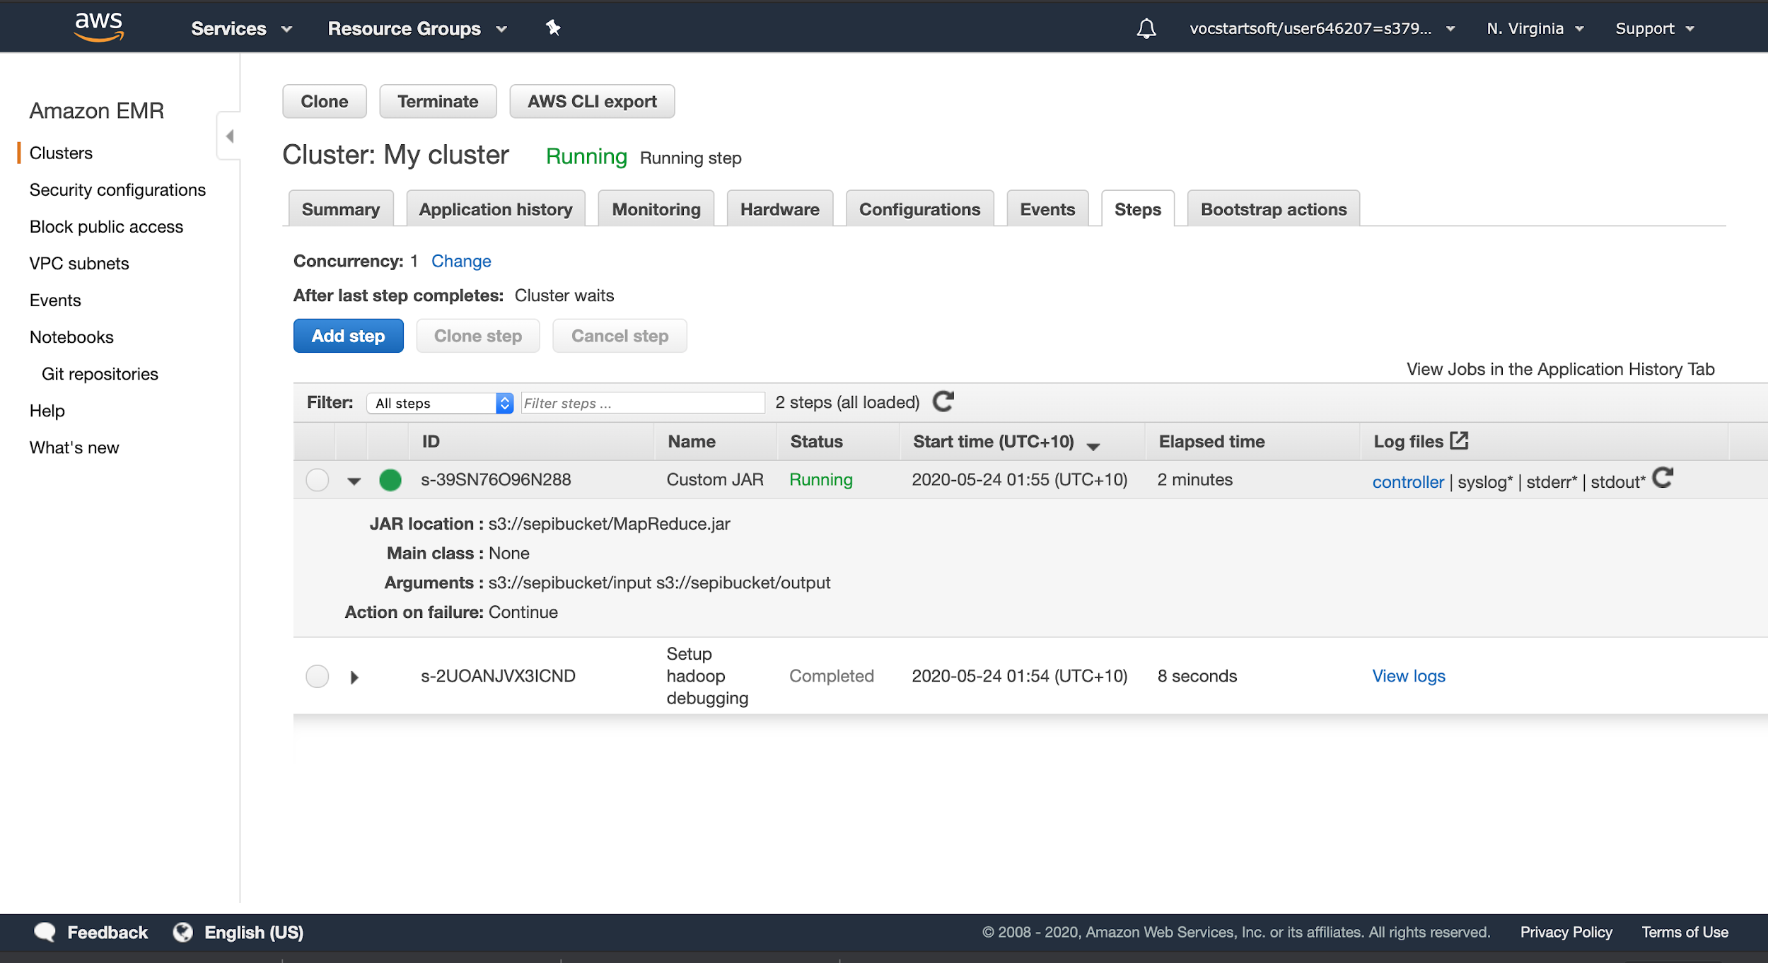

While the steps are running, we’re able to see the logs. The figure below shows the mapreduce procedure in the syslog:

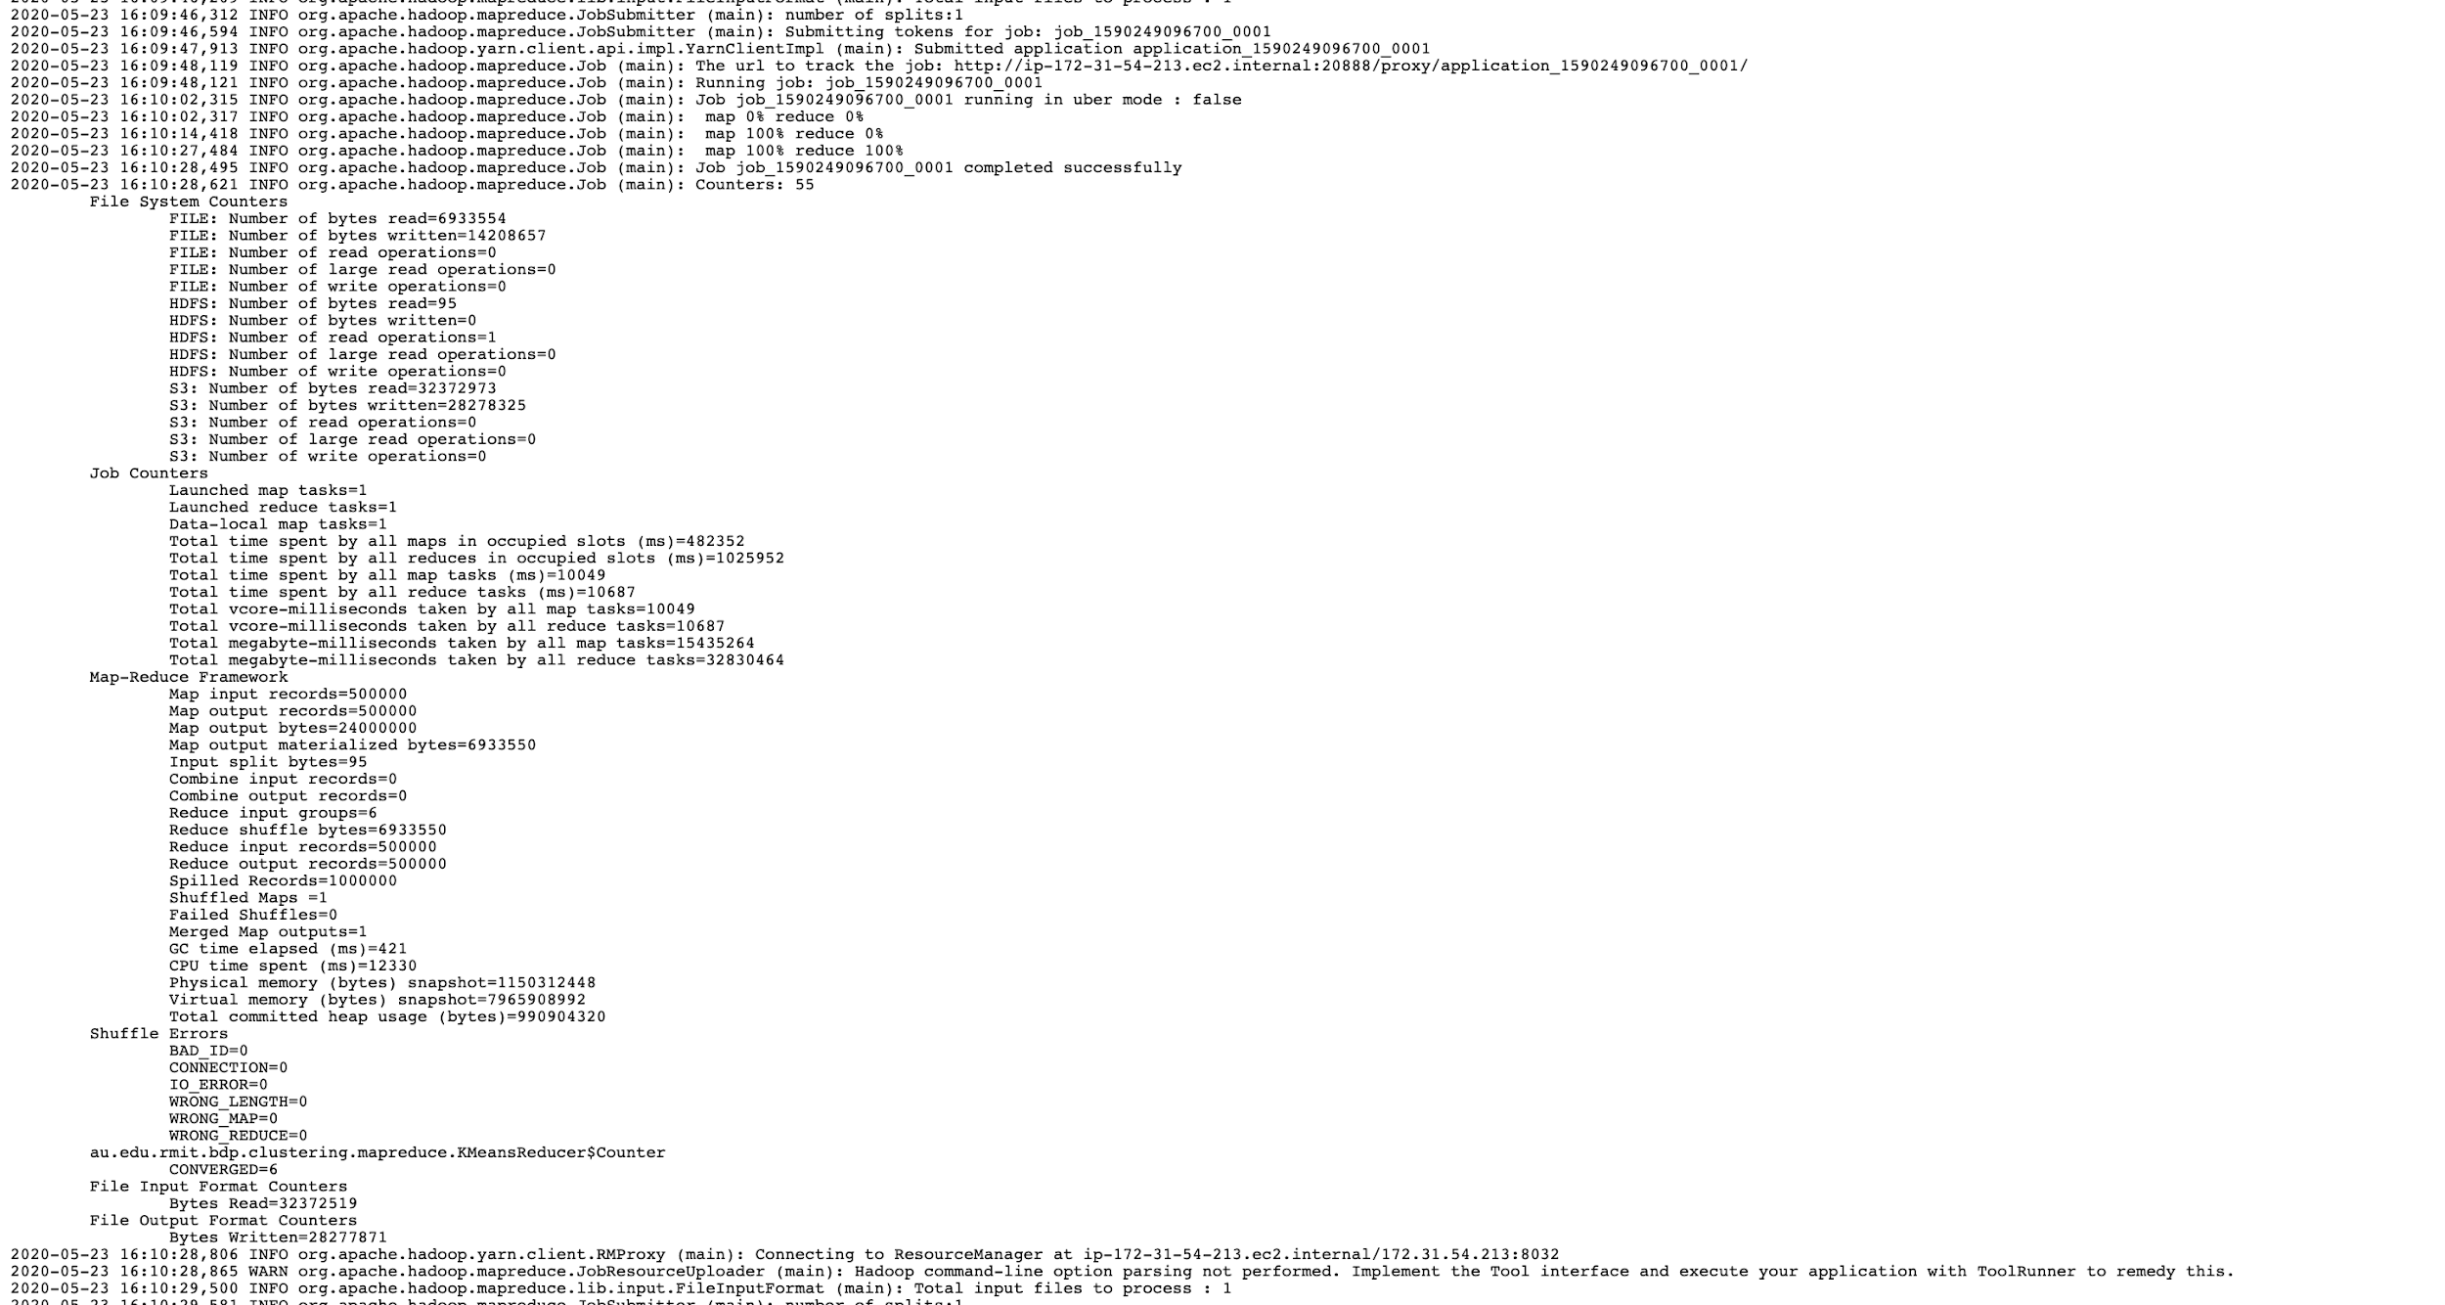

Depending on how many centroids we have, the MapReduce procedure takes longer time to complete. The completed task looks like the figure below:

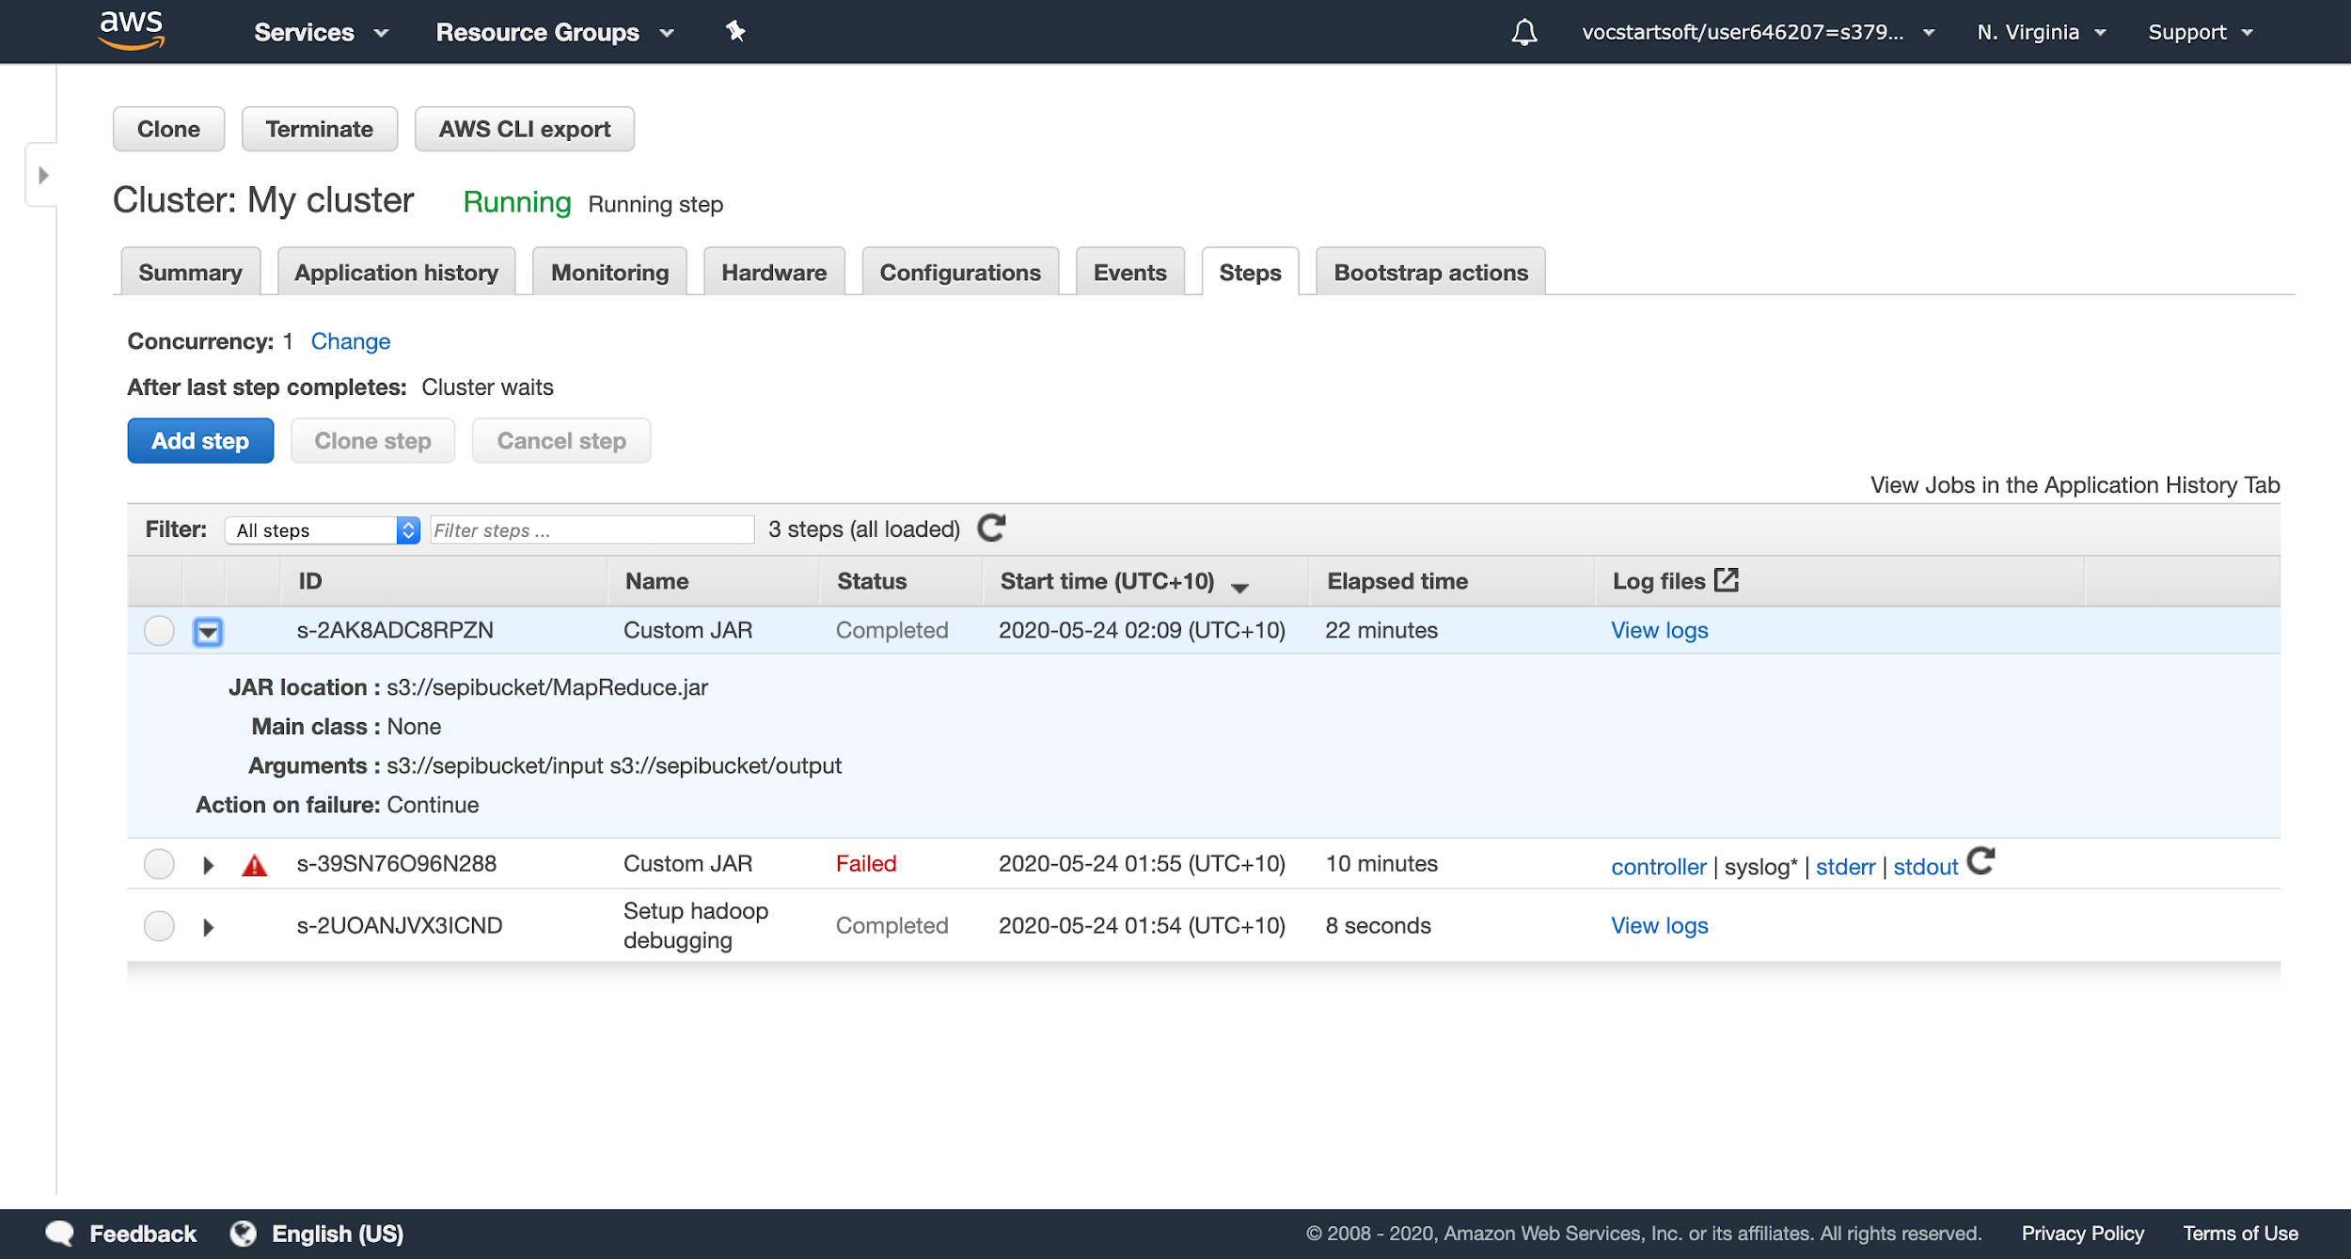

The Java program would write the output in the output folder as a text file in our s3 bucket when the step is completed, and it would also write the map reduce rounds in the output folder. Our s3 bucket would look like the figure below when the steps are completed (note that we created the input folder at the beginning and placed our 22mb.txt file inside the folder for the .JAR file to read from):

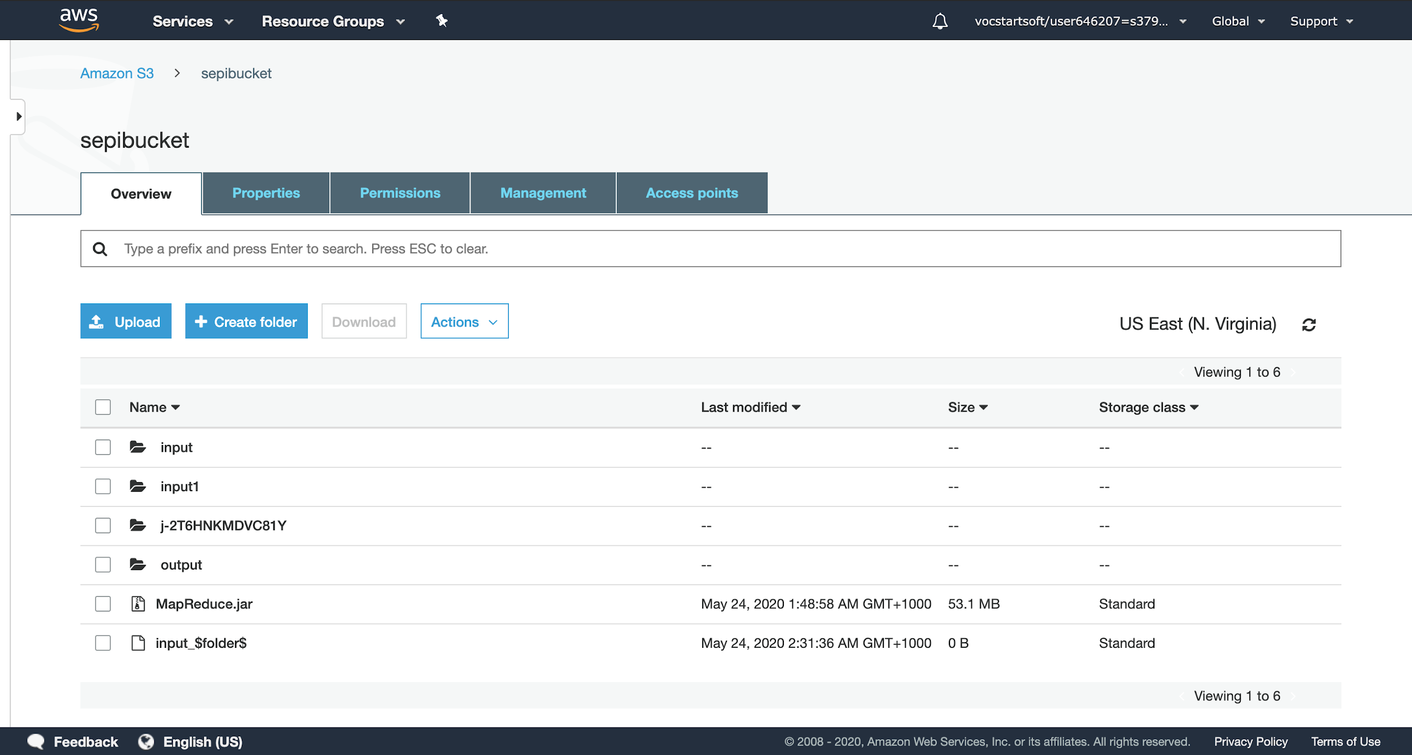

As shown above, our java program has created an output folder. If we had 4 centroids, it took 12 rounds of MapReduce, but for more precision, we used 6 centroids and it took 34 rounds of Mapreduce which is shown in the output folder below:

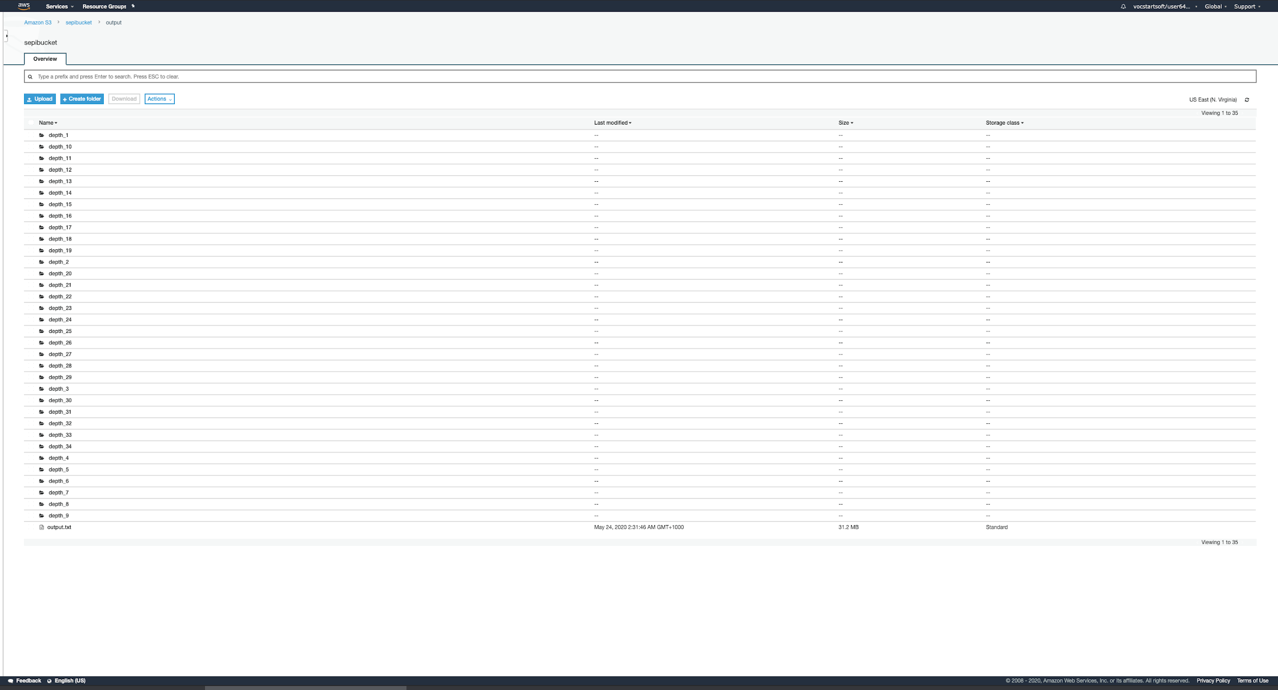

Inside each depth_(#ofRounds) folder would look like the figure below:

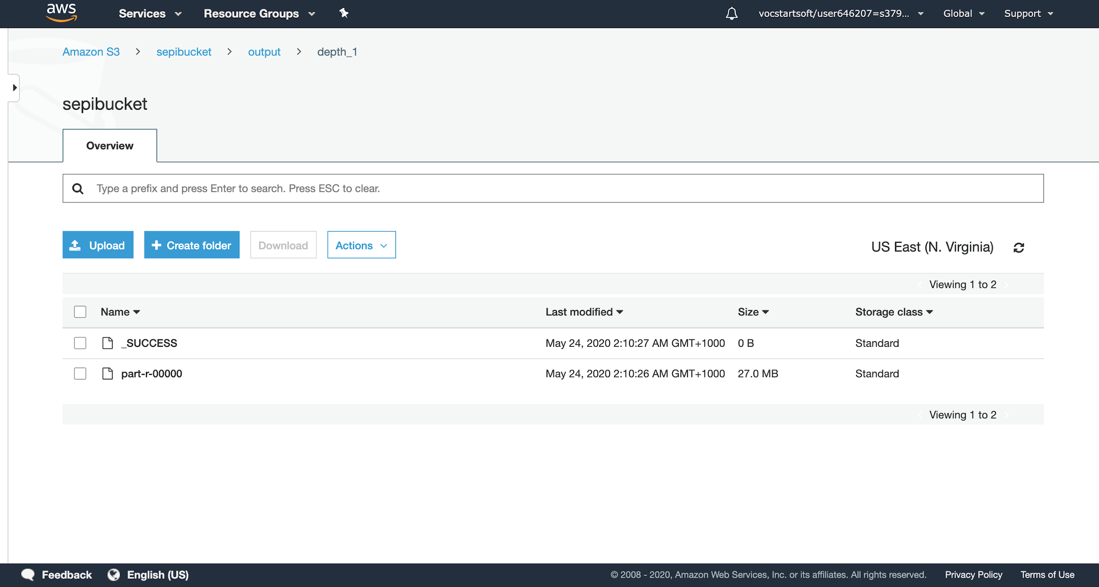

Now that out output is generated, we can move on to the data analysis and data visualization.

### 

### 

### 

### 

### 

### 

### Data Analysis and Data Visualization

We have done the data visualization through an R script and Google Cloud tools.

The image below shows the 6 different clusters from our output result, plotted by the R script we wrote for this purpose. We have placed the results of our R script in our host link using Google Cloud’s Compute Engine (<https://cloud.google.com/solutions/running-r-at-scale>) which would also show the image below when you open the link, but since it took a long time to plot the dots on the map, we placed a photo of the results for easier access:

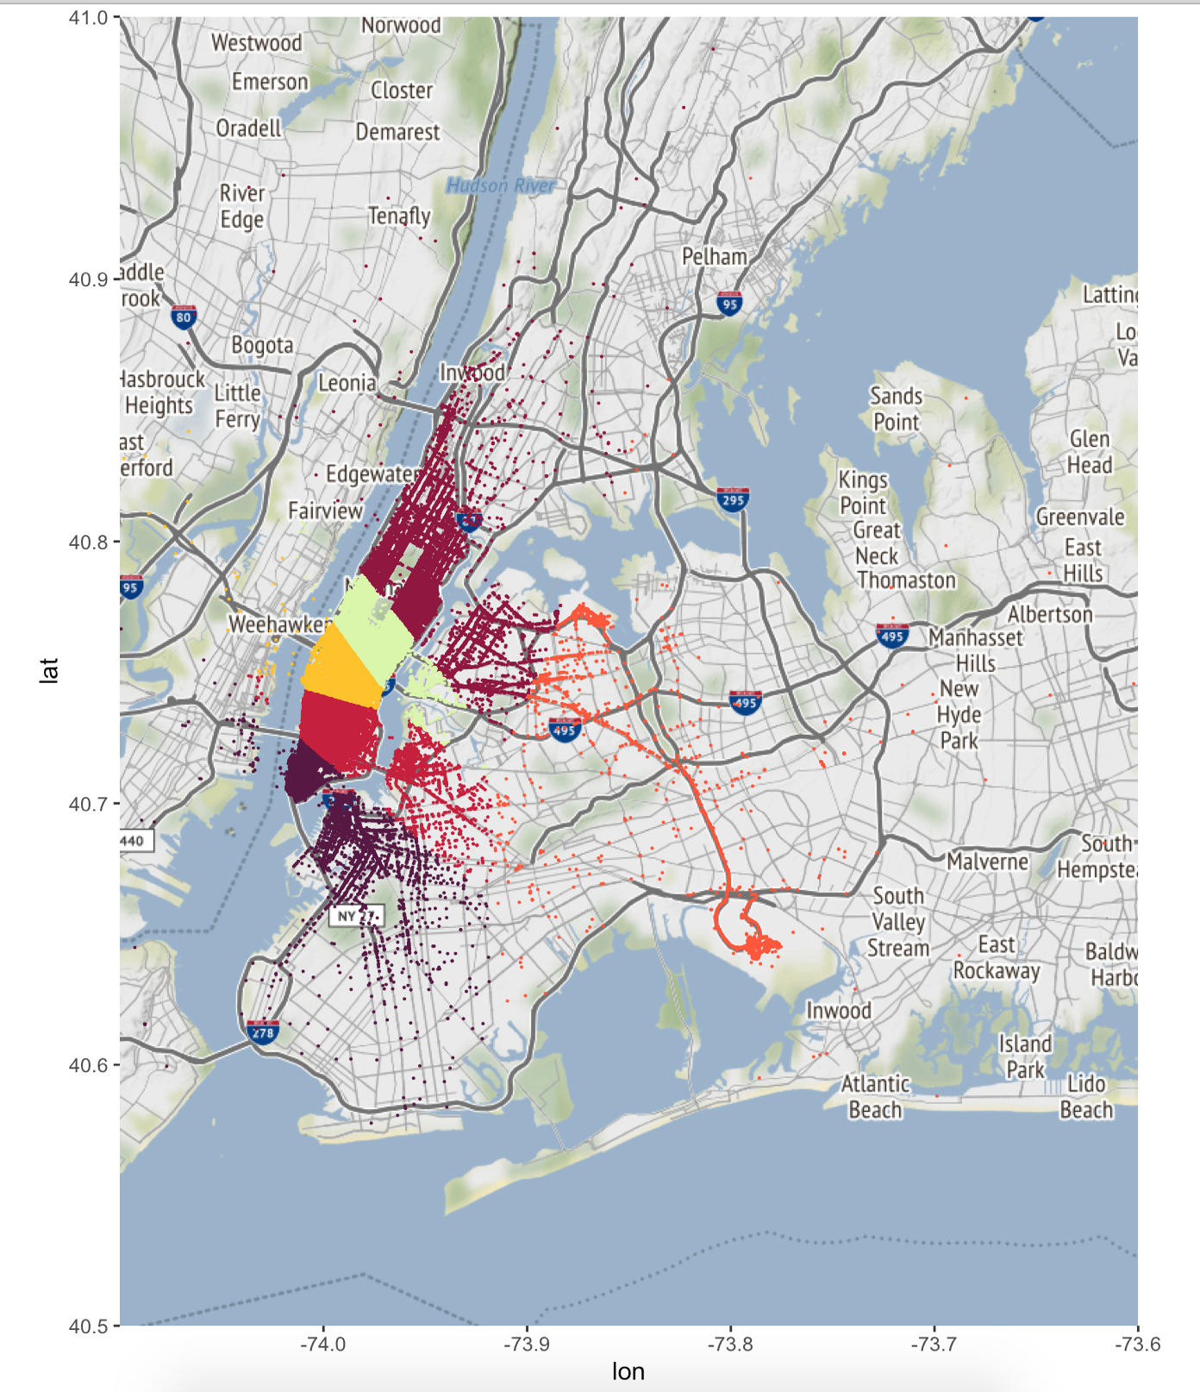

### BigQuery, BigQuery Geoviz and Datastudio

In order to be able to visualize and analyze the data more easier, we used BigQuery and create a dataset:

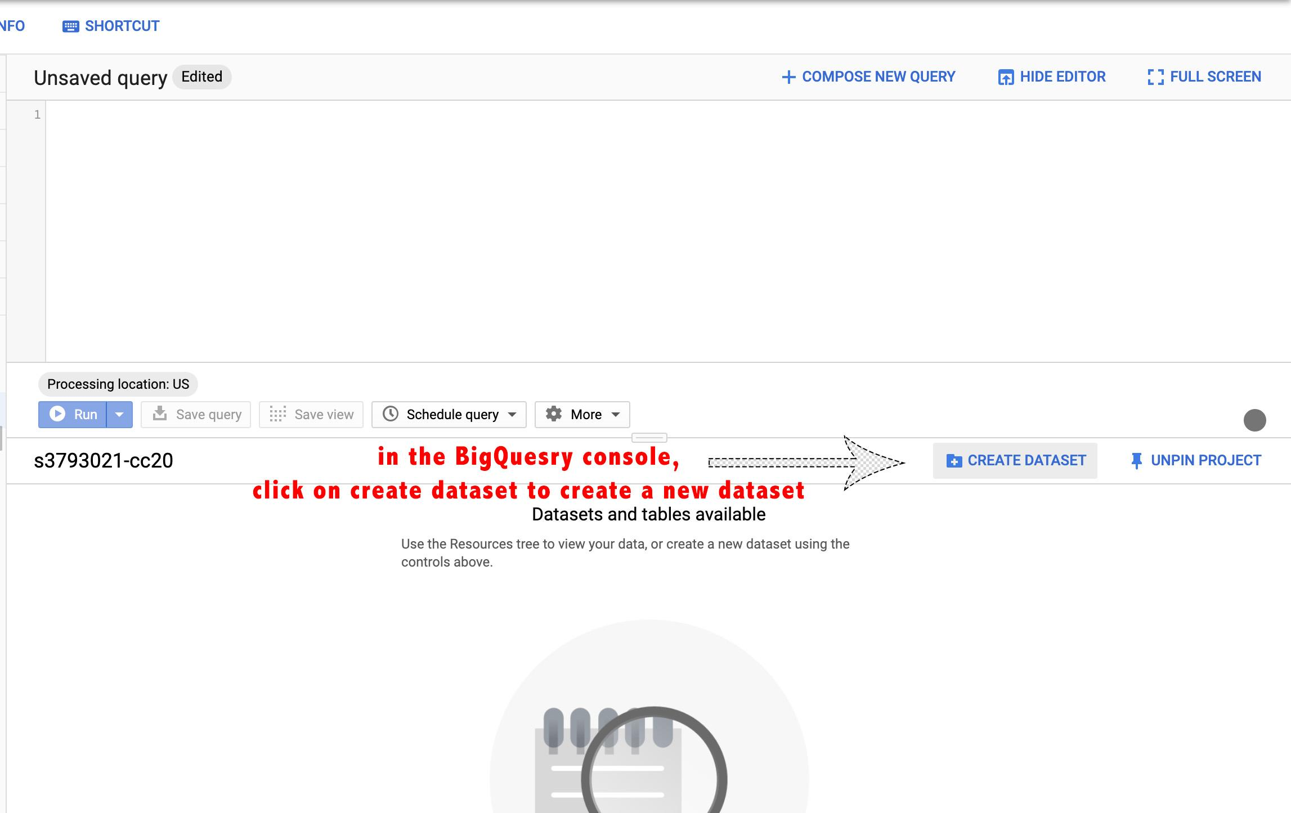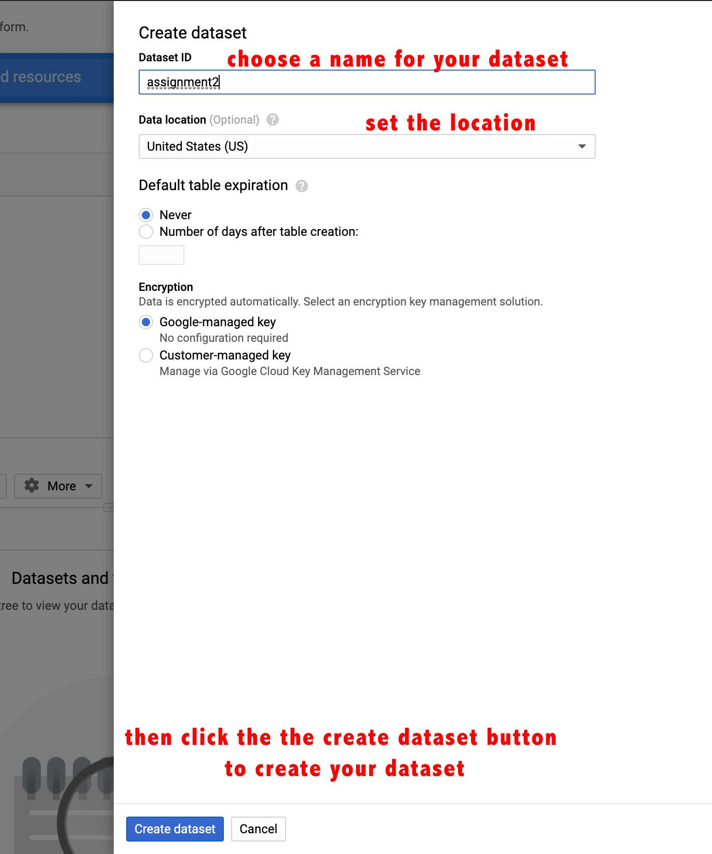

After successfully creating the dataset, we move on to create a table in the dataset:

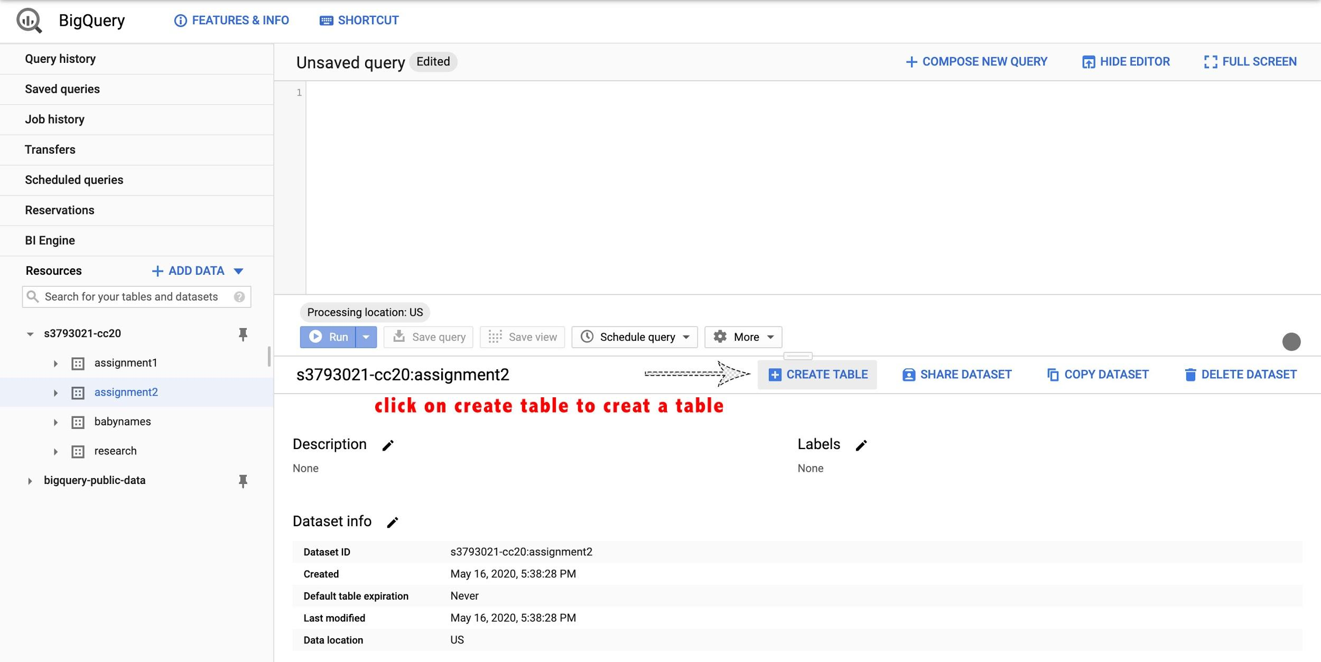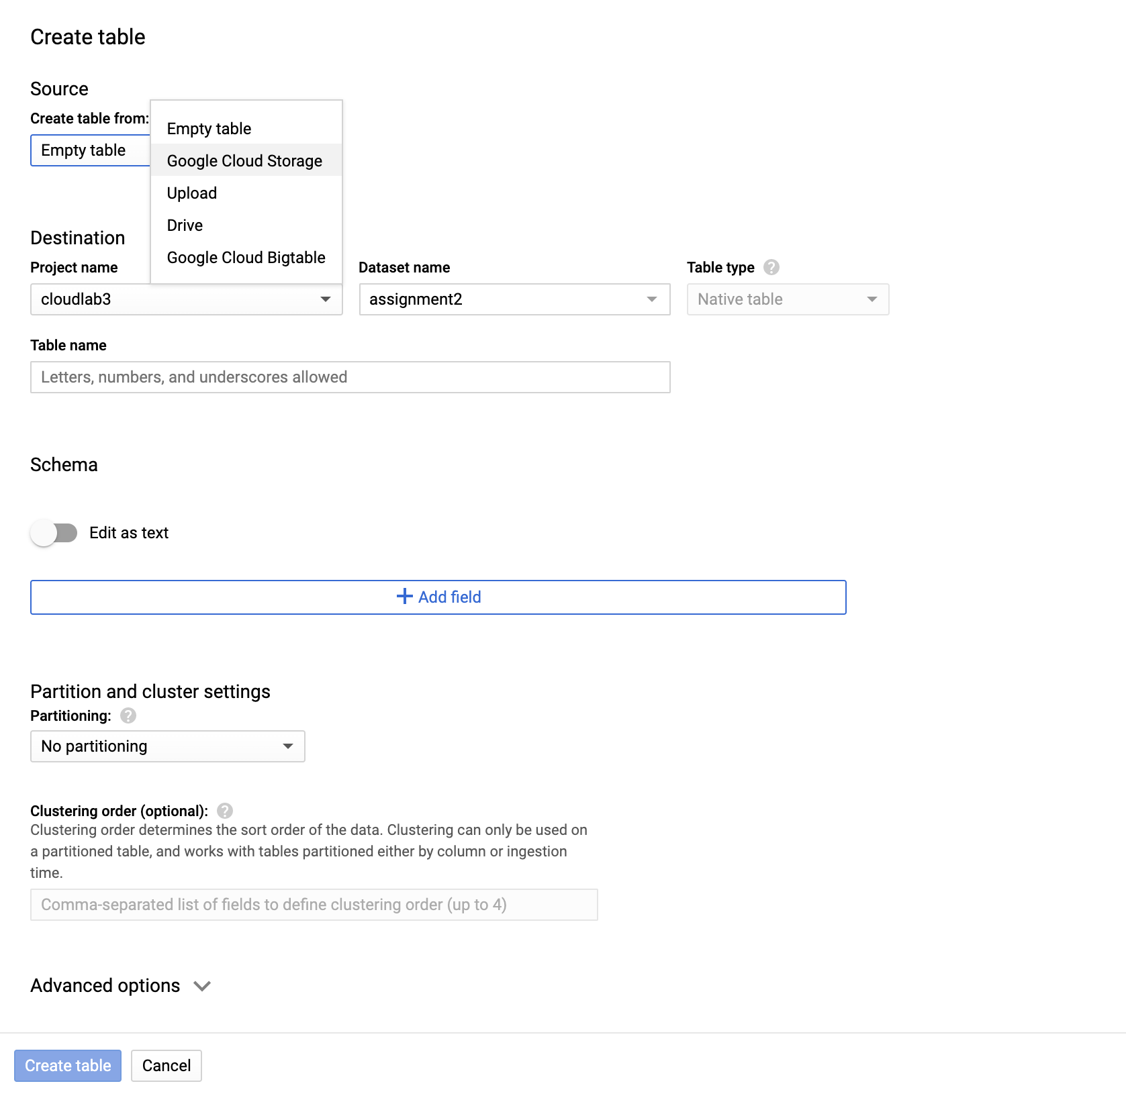

BigQuery doesn’t accept large size files to be uploaded from your computer. Instead we need to create a bucket in the Google Cloud Storage and upload our file there, and choose our file from the Google Cloud Storage to create our table (note that we have cleaned our output results and converted to a .csv format to be able to work with it easier).

Click on Create Bucket in the Google Cloud Storage, and choose a name for your bucket and create it.

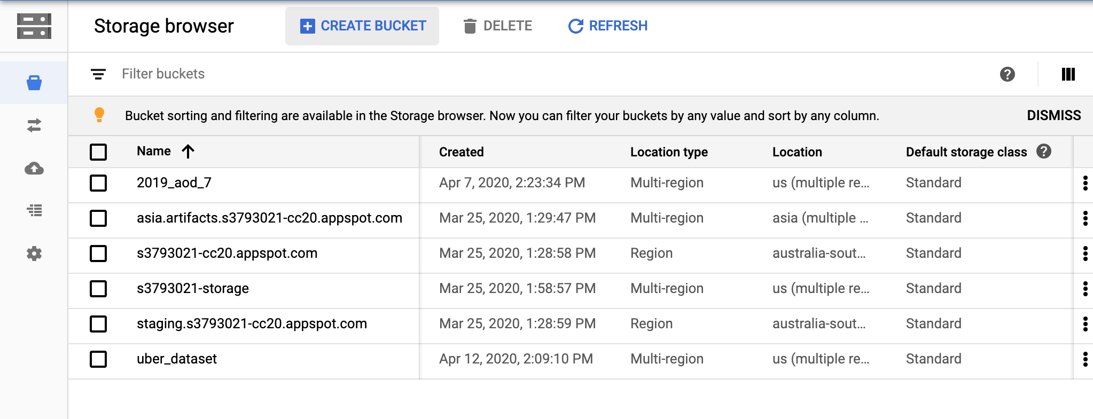

Then inside your bucket, click on Upload files and choose your file and upload it: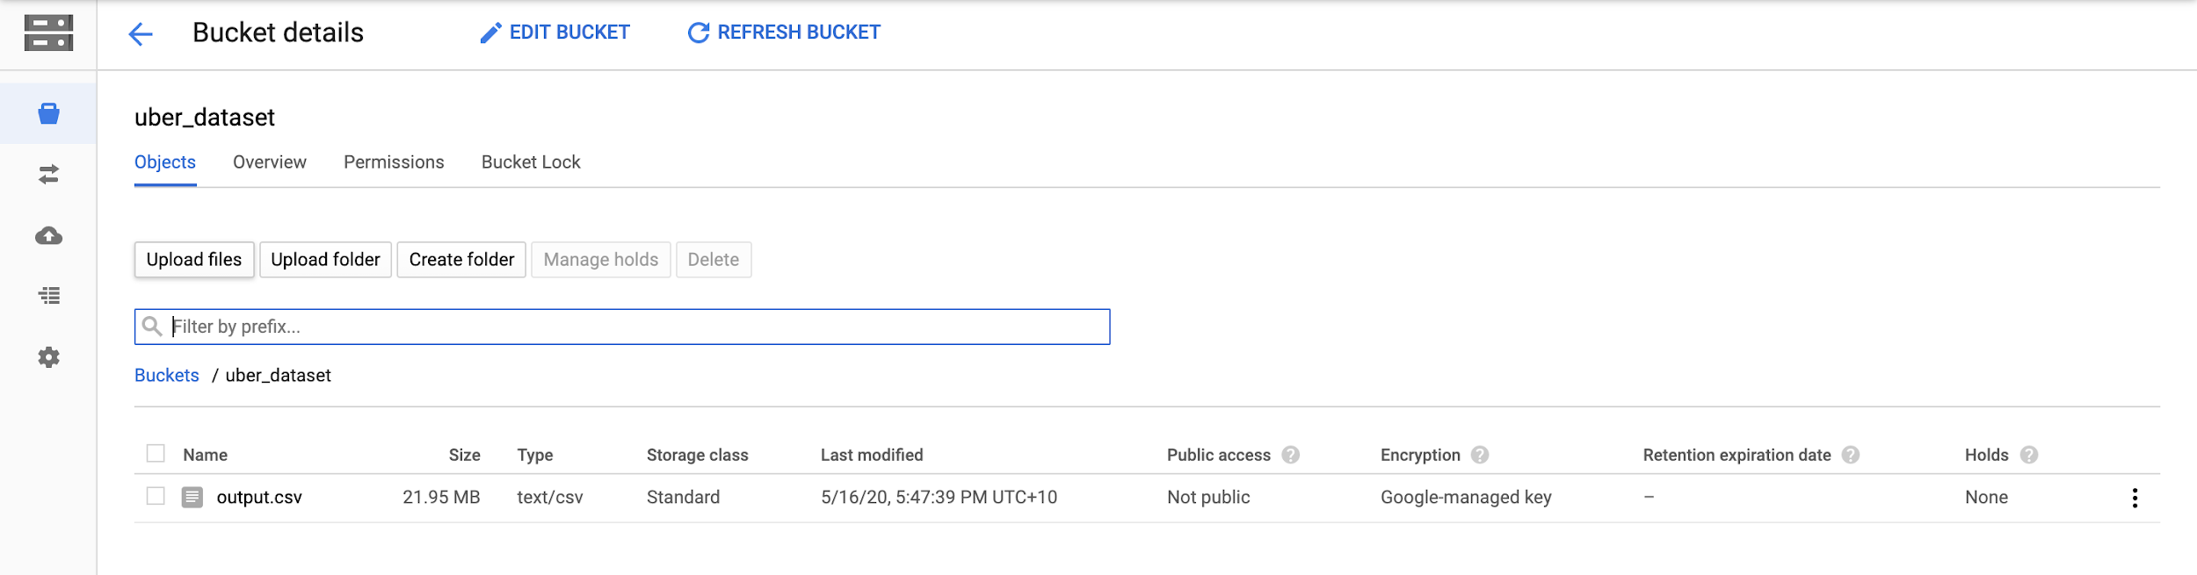

After uploading our file in the GCS, we go back to our create table stage and chose our bucket and the file we uploaded inside the bucket:



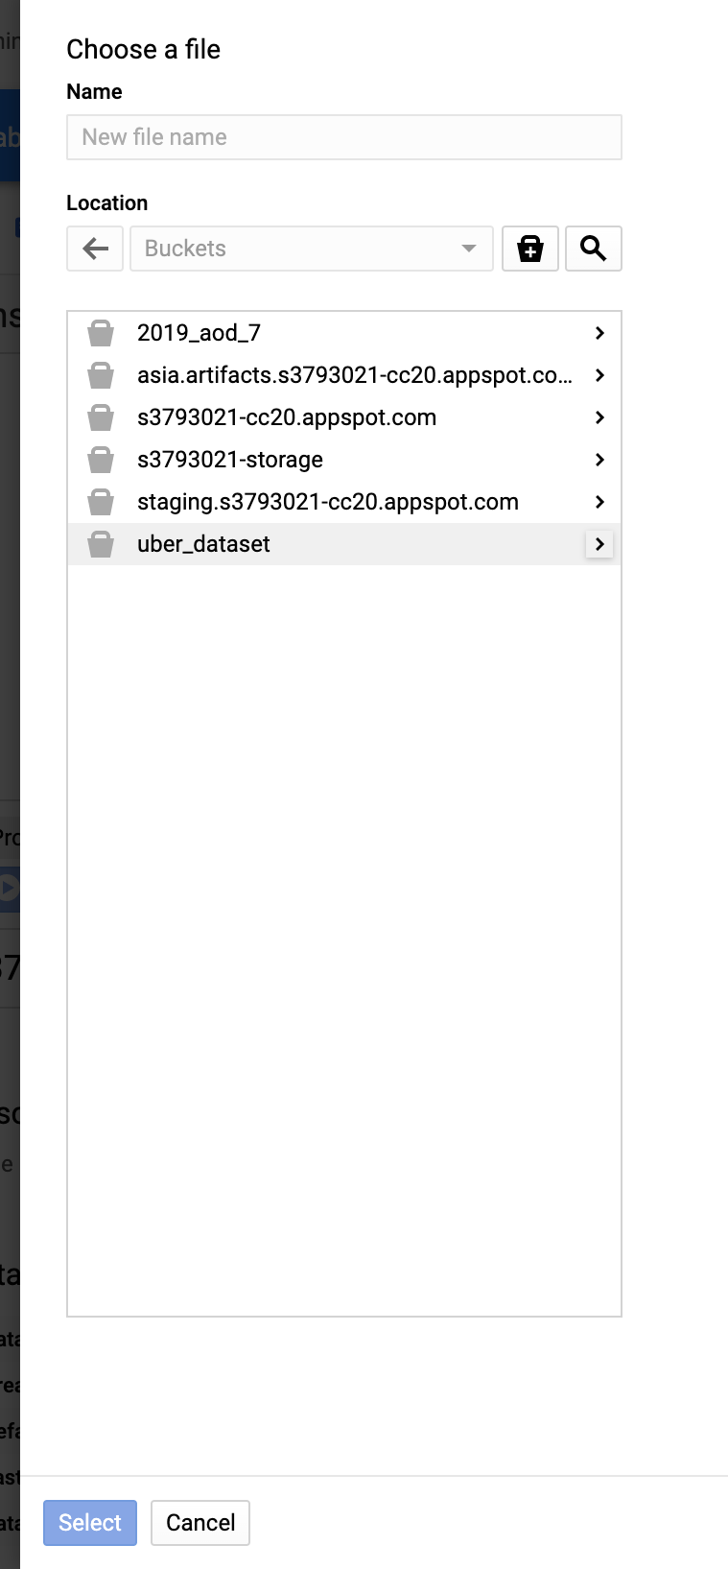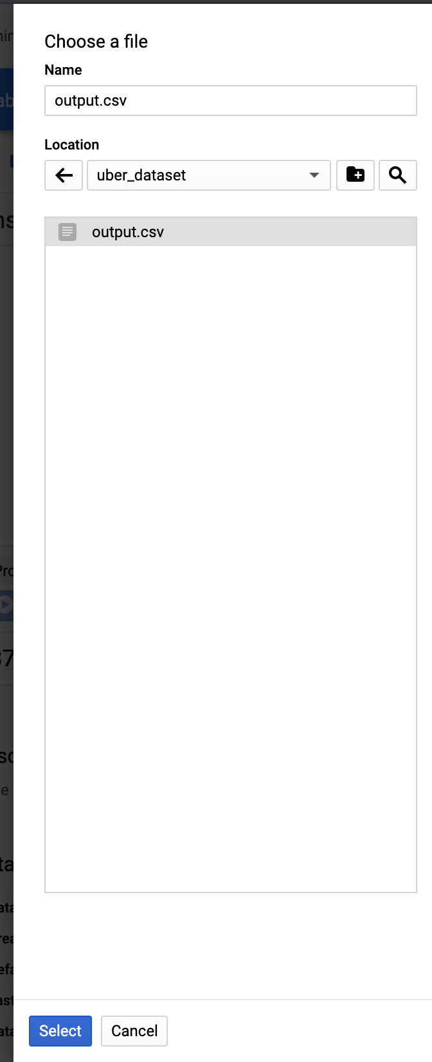

After choosing our file, we set the table name and let it create the table schema automatically and click on create table to create our table:

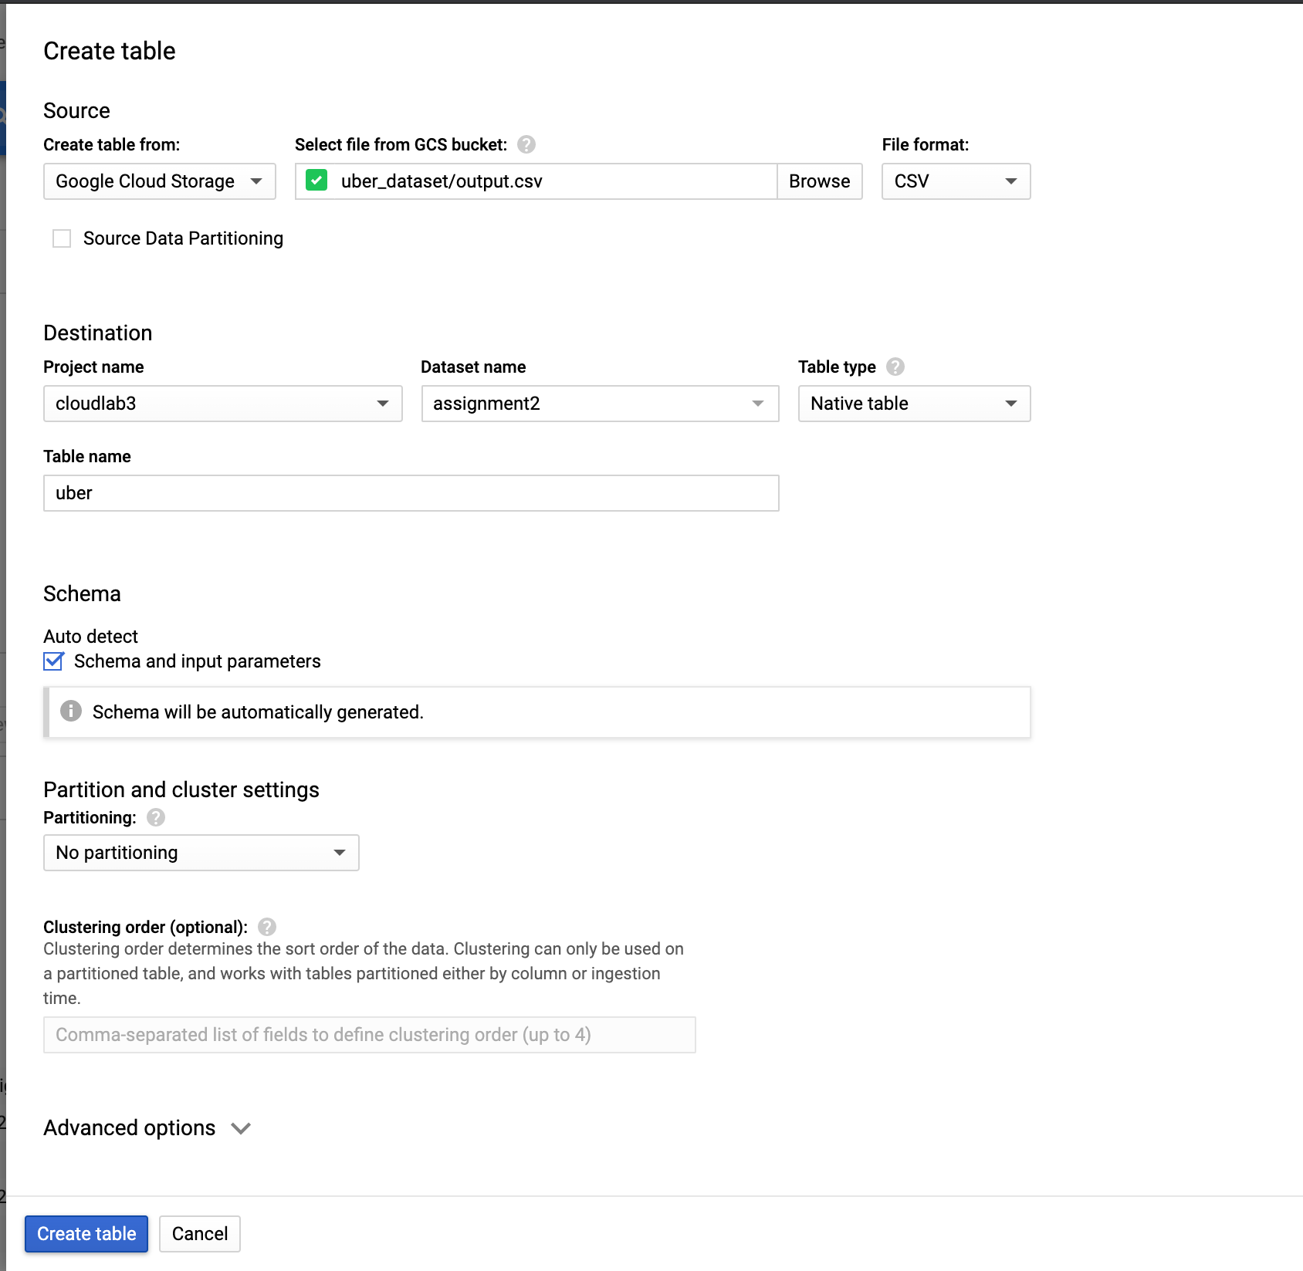

The table is now created and the resulting Schema set is shown below:

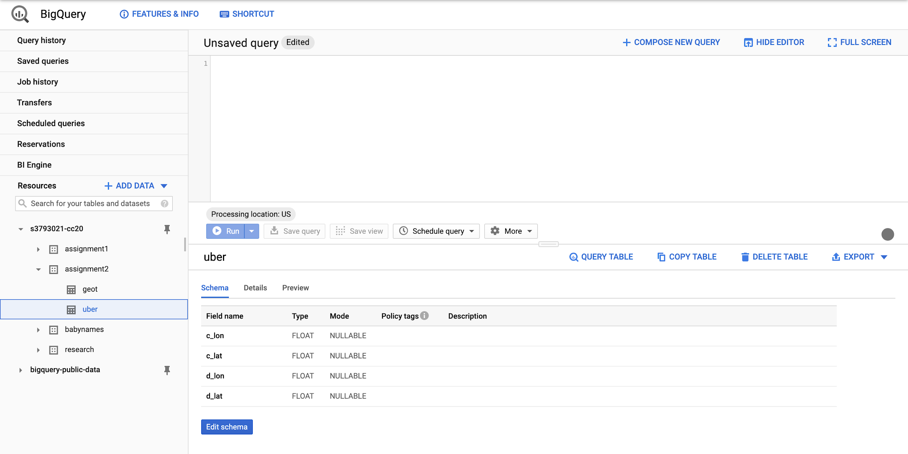

we can now move on to write some queries!

Our table has 4 columns consisting of the longitude and latitudes of the centroids of each cluster and the relevant data points, along with their longitude and latitudes.

There are 6 centroids in total, in which, some clusters have higher density of data points in comparison to others which we will show how to visualise them in a bit.

We used BigQuery GeoViz to visualise our data on Google Maps which you can find more information about it through the link below:

<https://cloud.google.com/bigquery/docs/gis>

Using this piece of code below, we recognized the 6 distinct centroids:

select distinct c_lon, c_lat from `s3793021-cc20.assignment2.uber`

order by c_lon desc

Row c_lon c_lat

1 -73.83285959 40.71803819

2 -73.95690754 40.78191267

3 -73.97519054 40.76314616

4 -73.98910809 40.74992504

5 -73.99346227 40.73054202

6 -74.00926104 40.70693079

And by using this piece of code below, we were able to get the density of each cluster in the datastudio report environment:

select c_lon, c_lat, d_lon, d_lat from `s3793021-cc20.assignment2.uber`

order by c_lon desc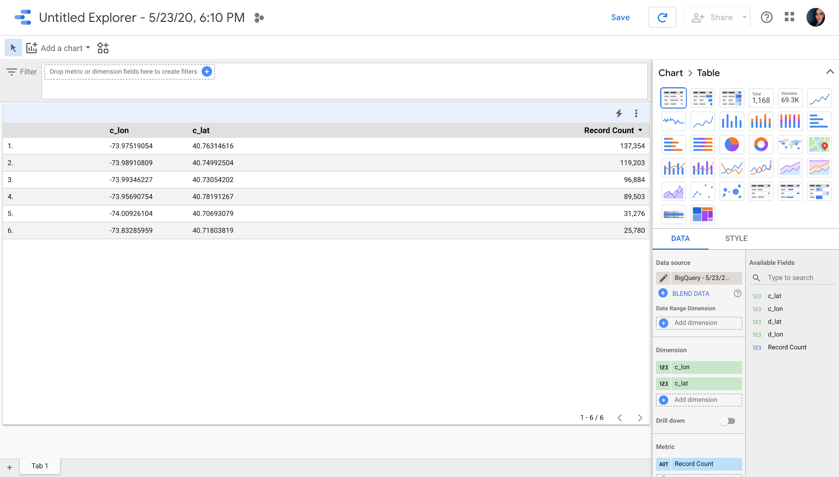

The below diagram shows the high demand centres of the clusters. We used BigQuery’s Data Studio to plot this pie chart as the results from the above query:

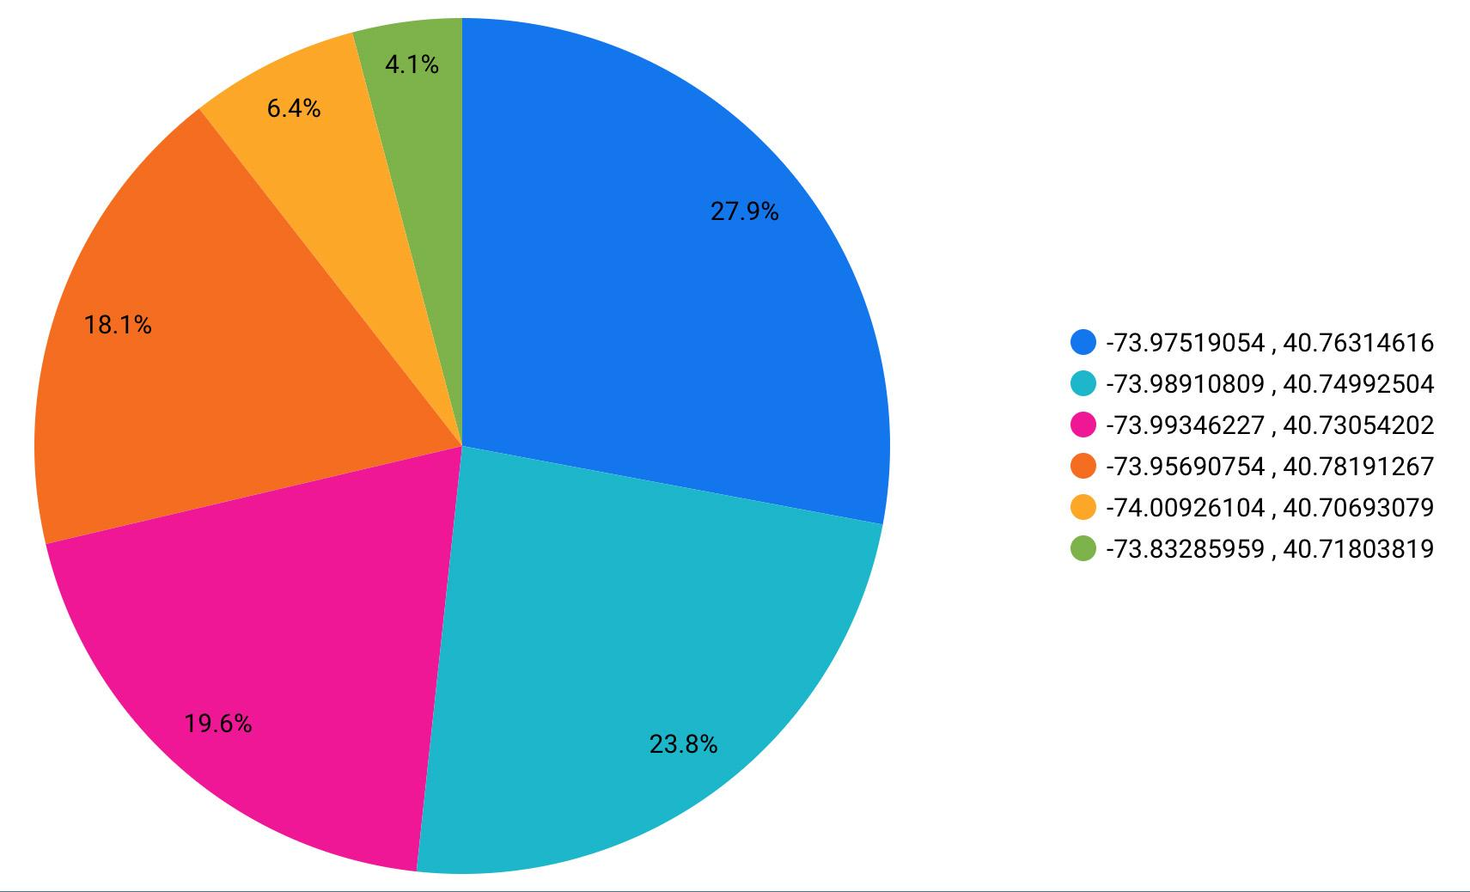

These diagrams show that there are clusters that have slightly more requests in comparison to other clusters, which means those areas are more busy areas and the density of requests in those clusters are higher.

For visualising the data, we use the below Query:

select ST_GeogPoint(d_lon, d_lat) as geo, c_lon, c_lat from `s3793021-cc20.assignment2.uber`

By using the ST_GeogPoint(Longitude, Latitude), we enable the GeoViz feature and we can plot our data points. After running the query, we click on Explore Data and then in the menu we choose Explore with GeoViz:

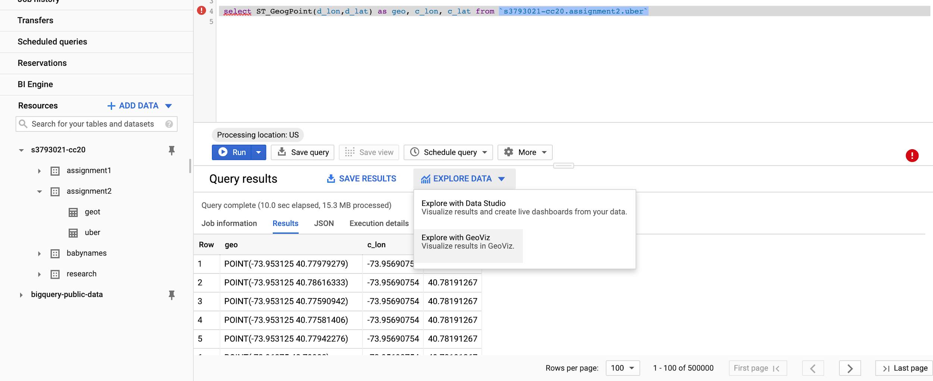

The results would be like the below figure:

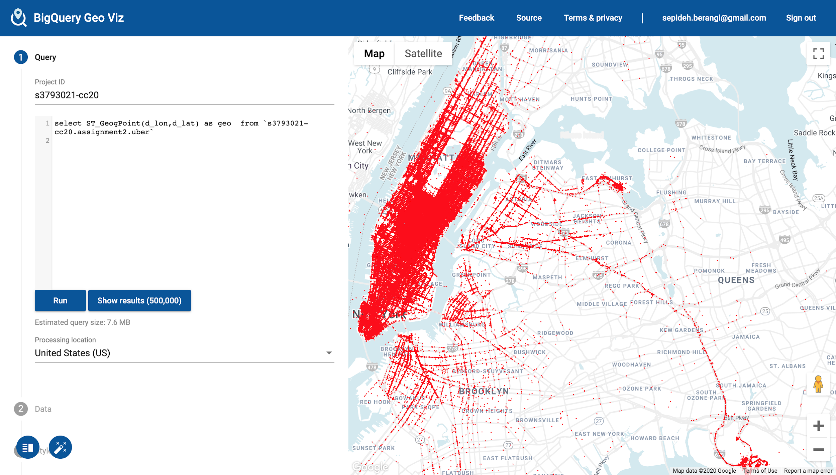

In order to show each cluster with different colors, we enable the data driven option on the 3. Style/fillColor section, then we insert each centroid longitude/latitude in the domain area, and set a specific color for each cluster:

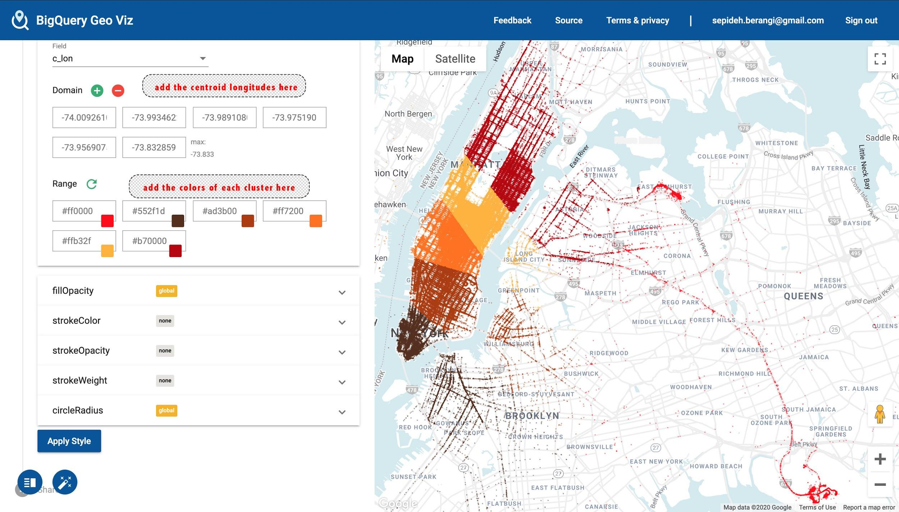

A more clear result is shown below:

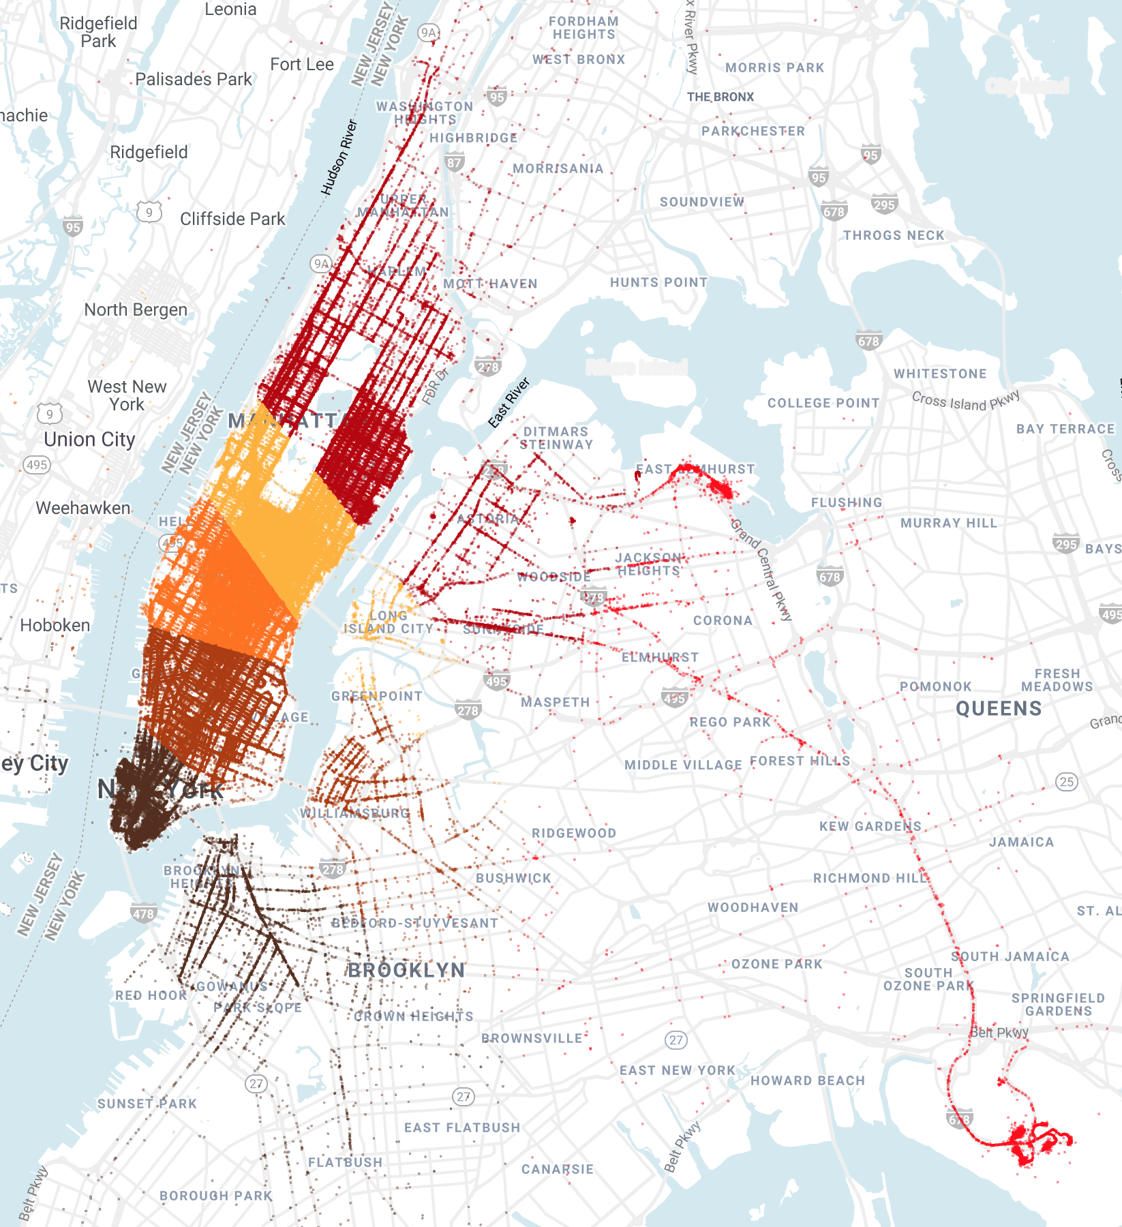

The more attributes you select in the query, gives more information on a point in the map. You can easily click on a random datapoint on the map and see the information of the datapoint like the figure below:

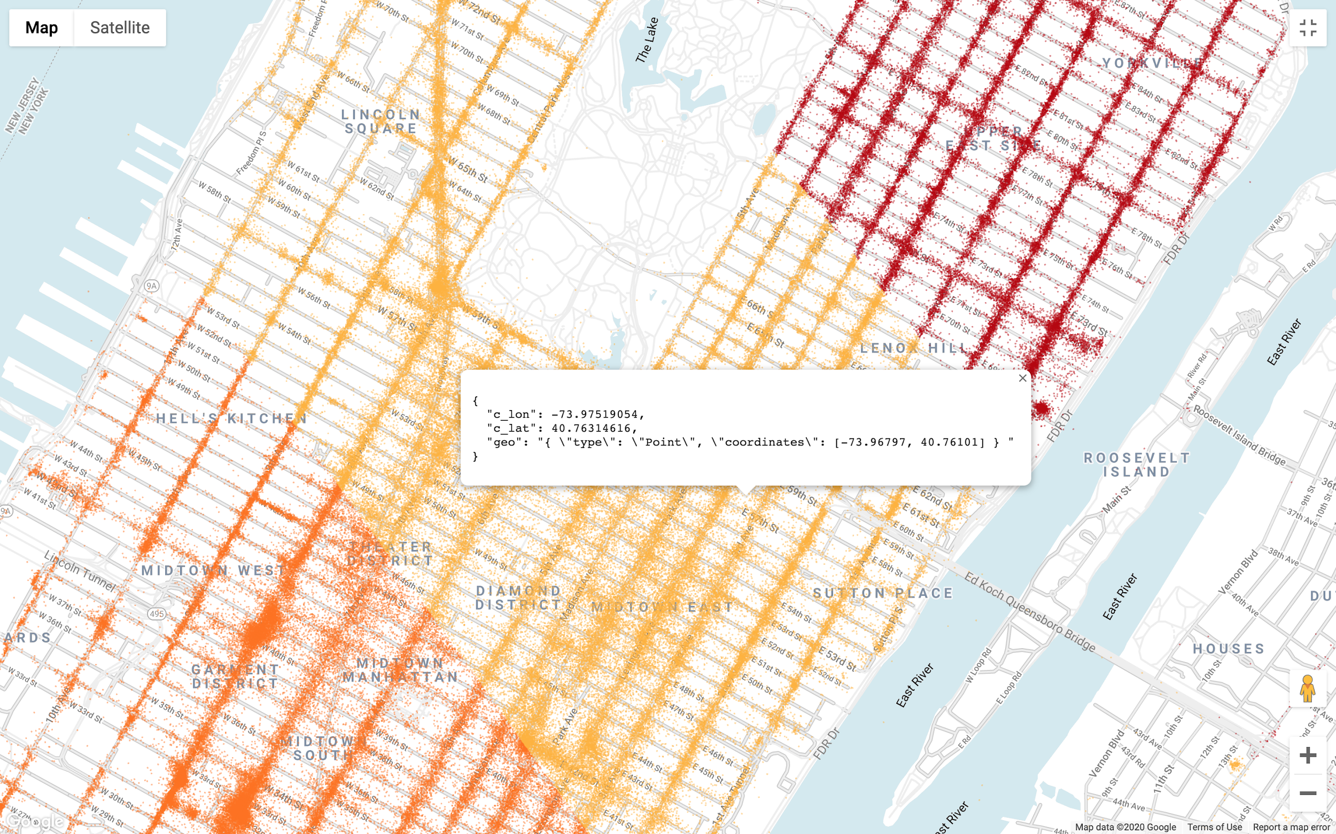

There are approximately 500,000 data points in our dataset which results in a very high density while visualizing it. In order to identify the busiest locations on the map, we would decrease the opacity of the data points in the same 3. Style section, fillOpacity in GeoViz, to highlight the most crowded areas. Below we have shown 4 different opacities and how each would show the density of data:

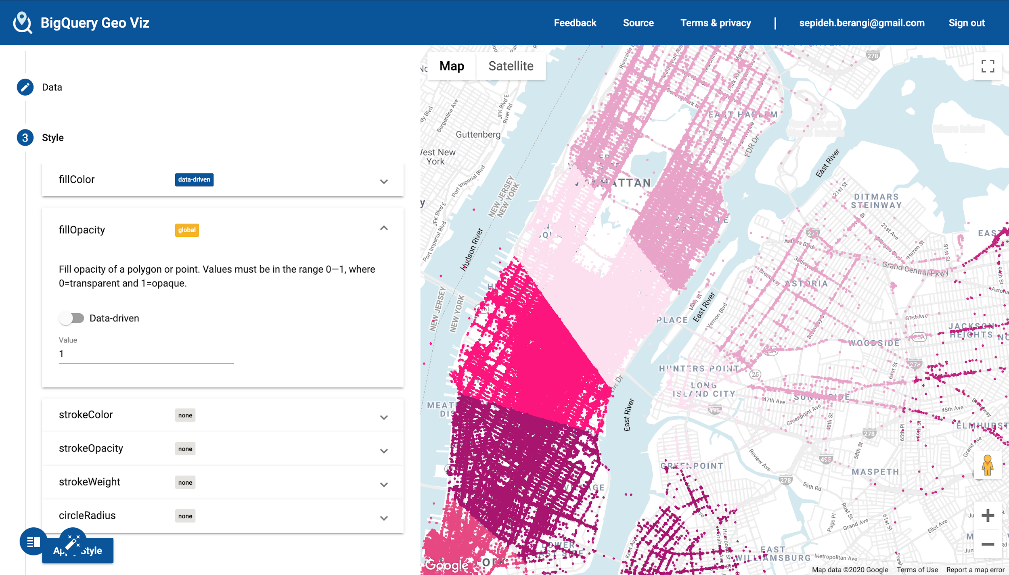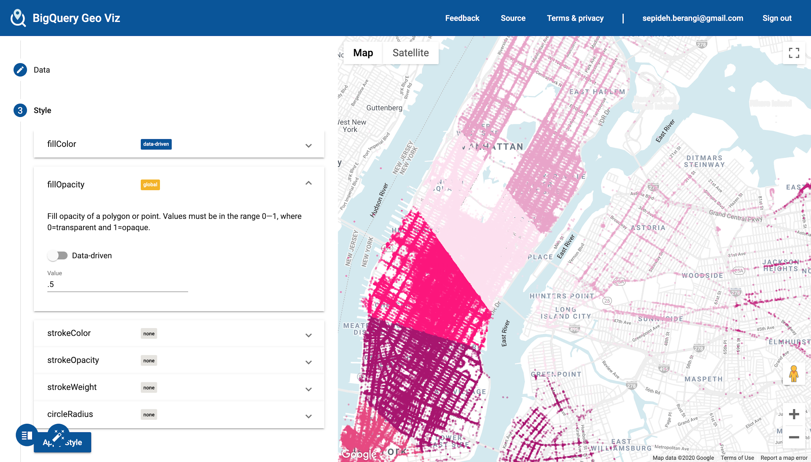

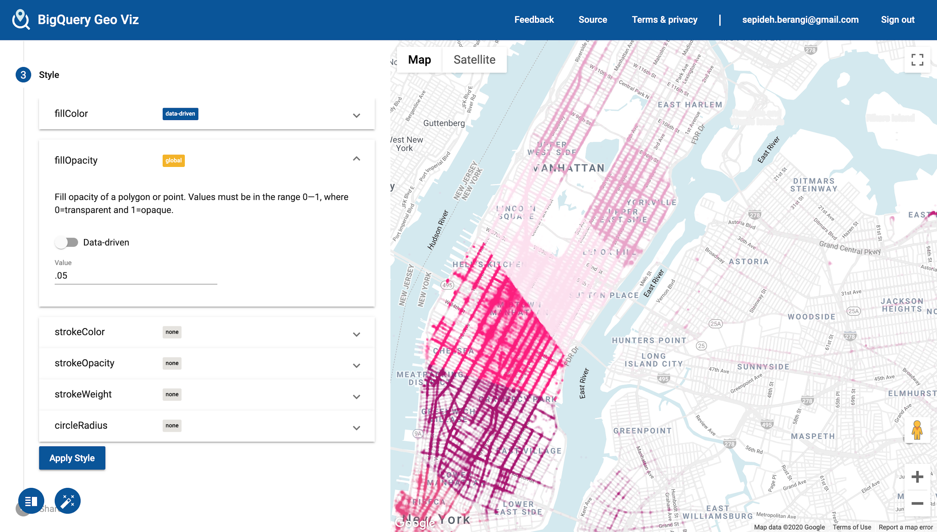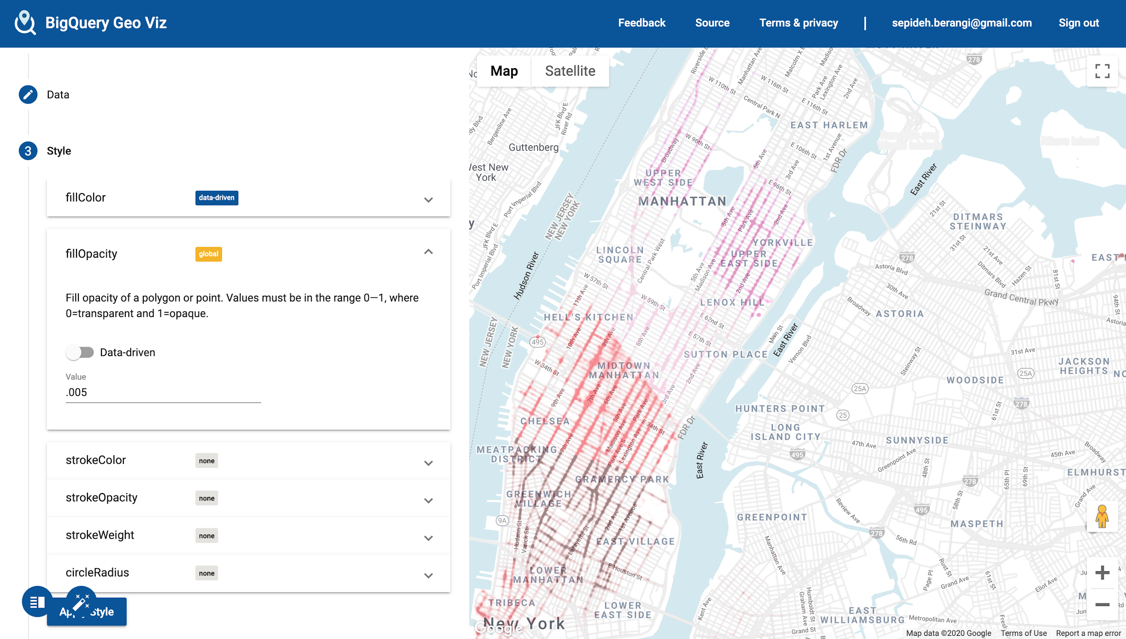

### User Manual

1. Install the application from Google play store or run the application from Android studio

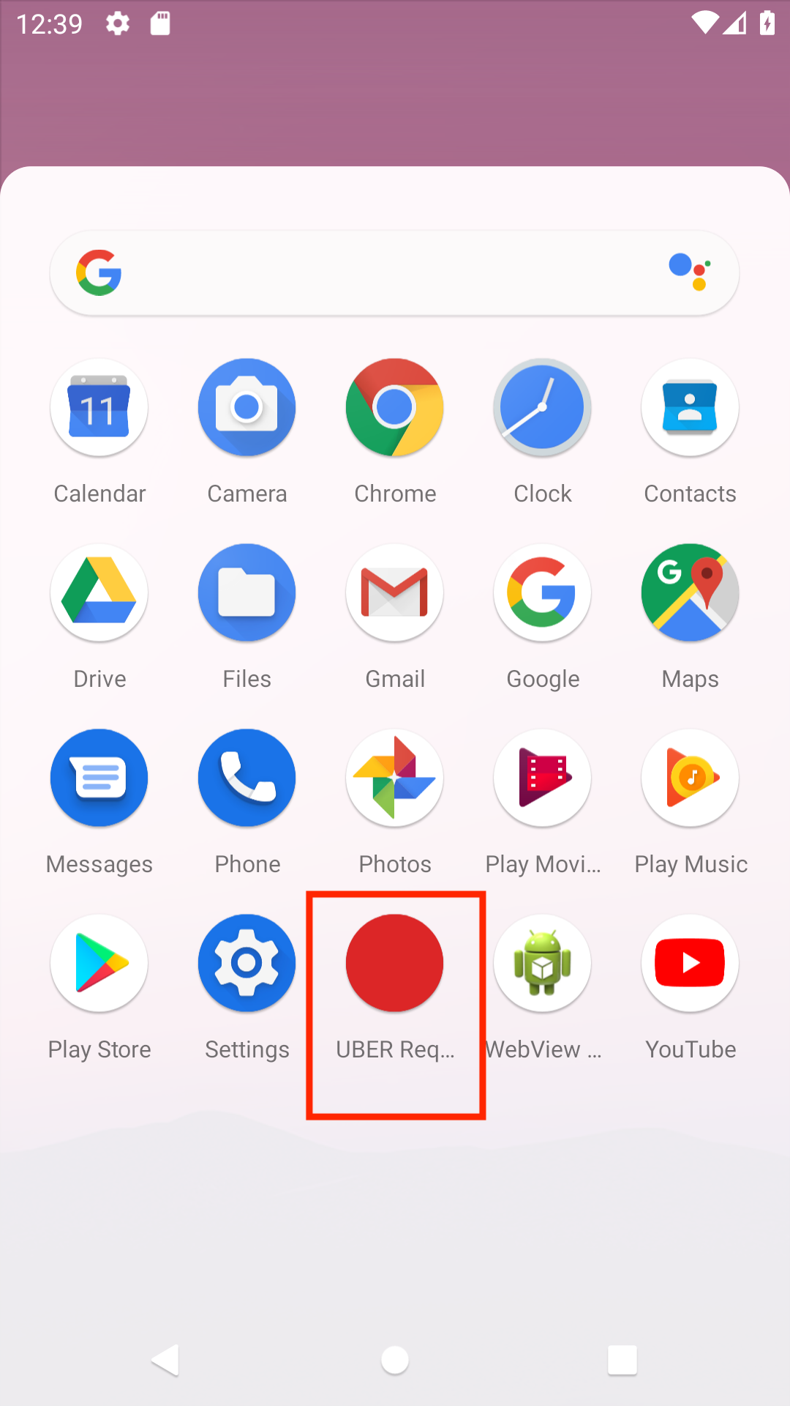

1. Login to the application in a way you prefer. in this example the email login was selected with password 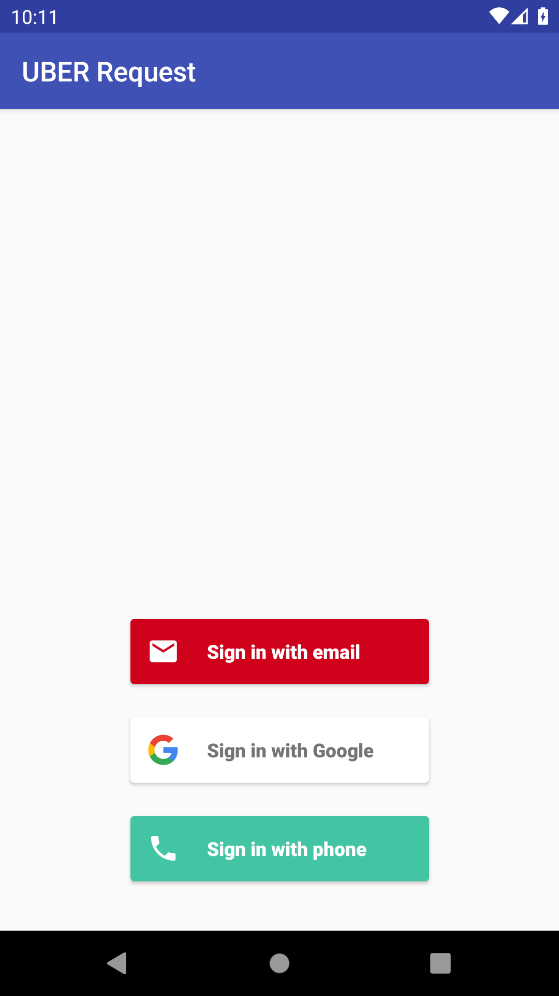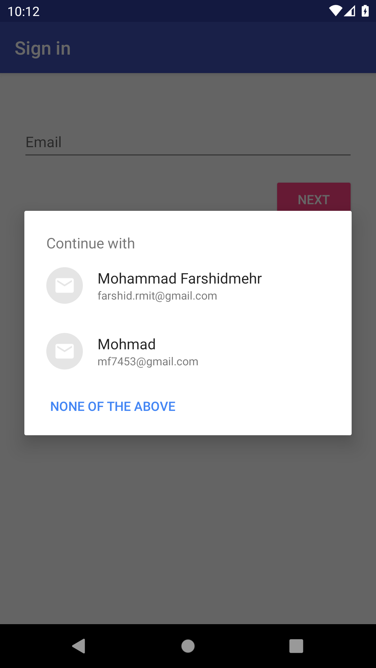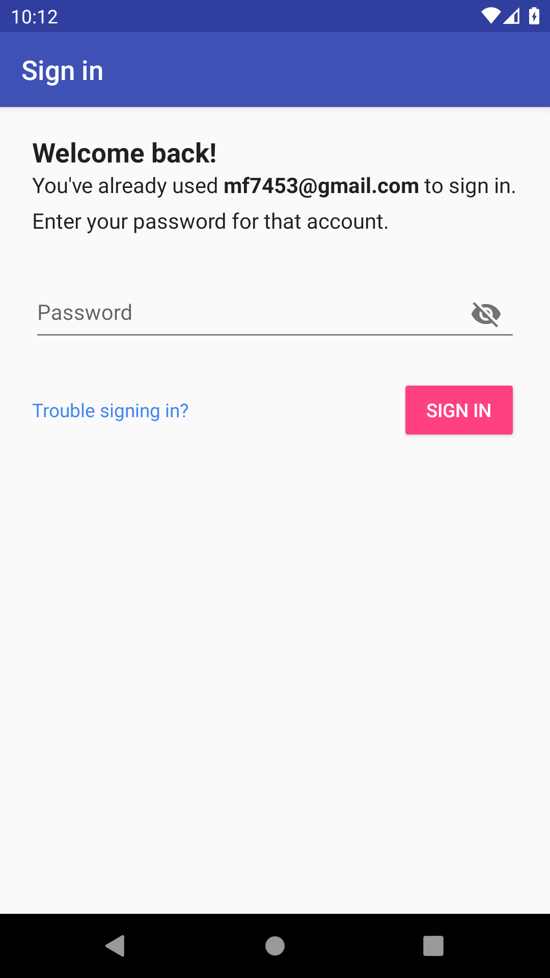
2. Main menu has 5 options. Sign out button to sign out from application and will see the main login page.



1. Second button is Show analyse web that shows the results of the analysis in a php web page

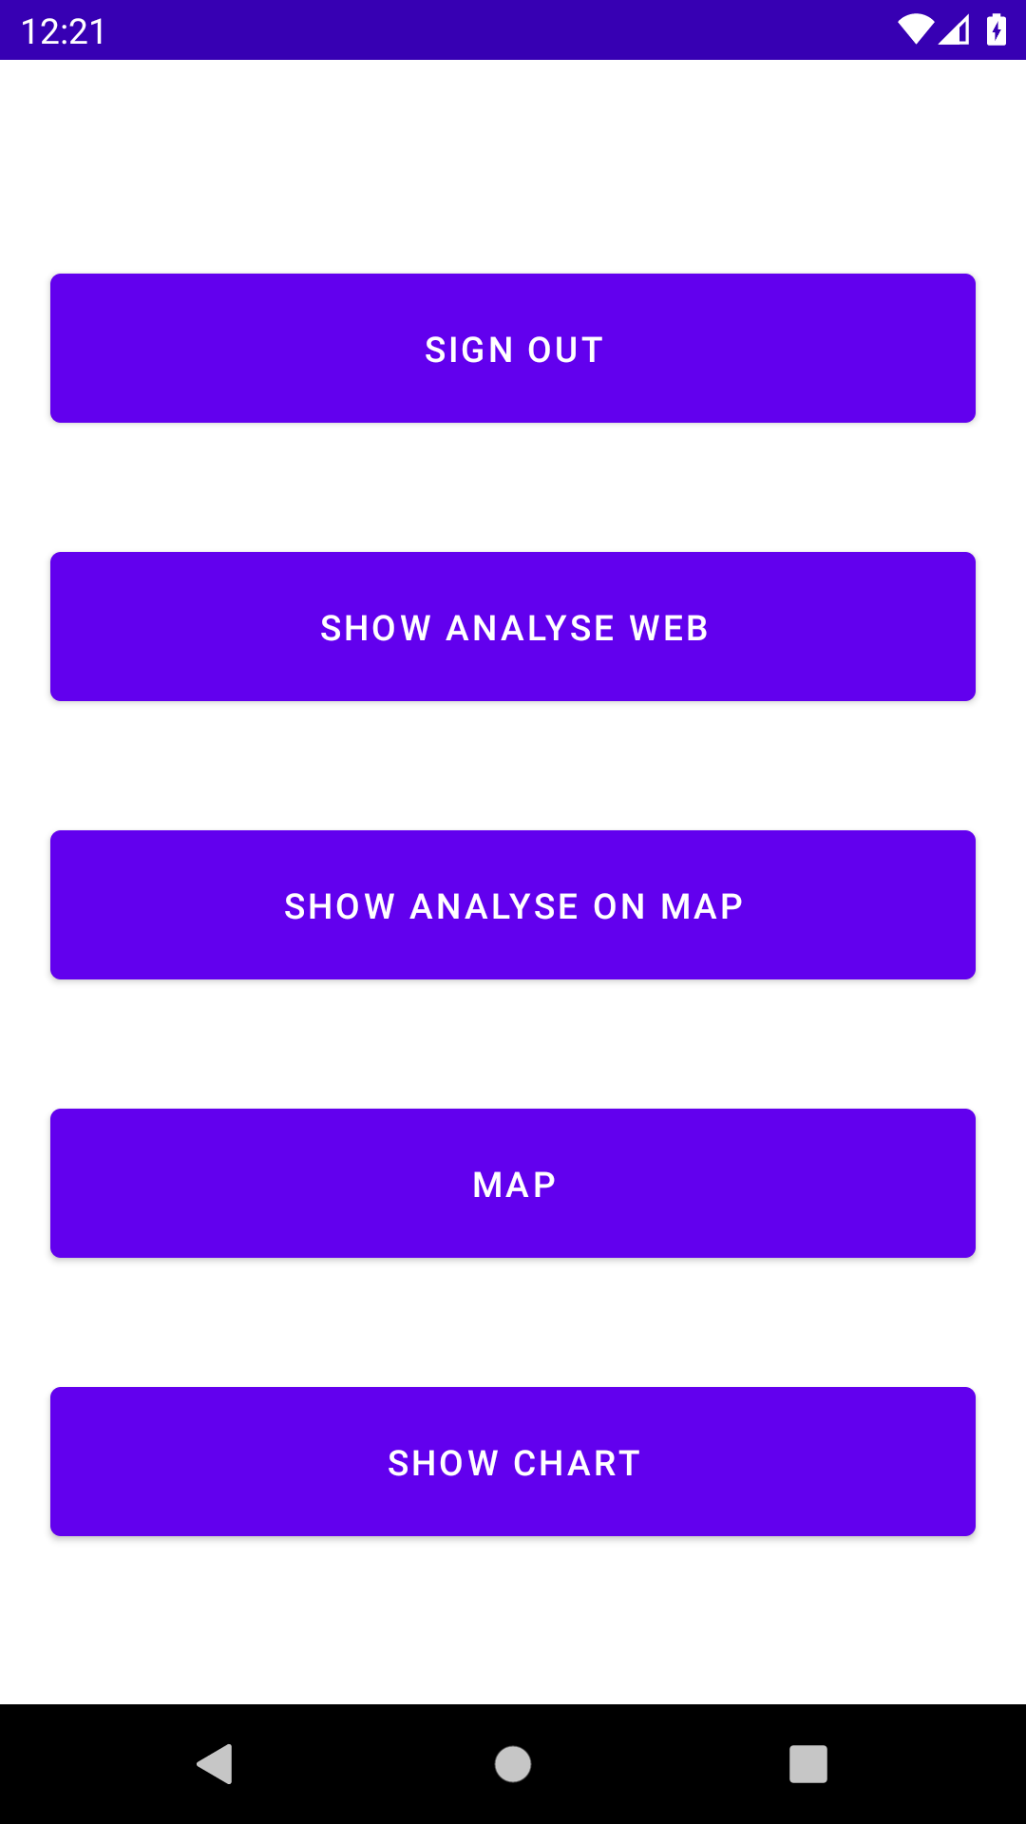

1. Shows points in map, that shows the points from the database and then shows the result in the map that draws a circle around the points which are centroids of the clusters

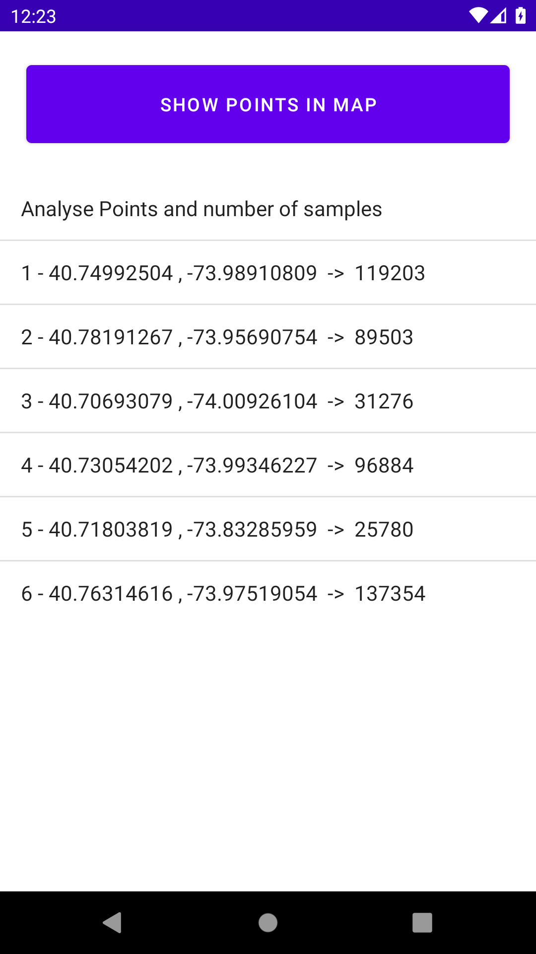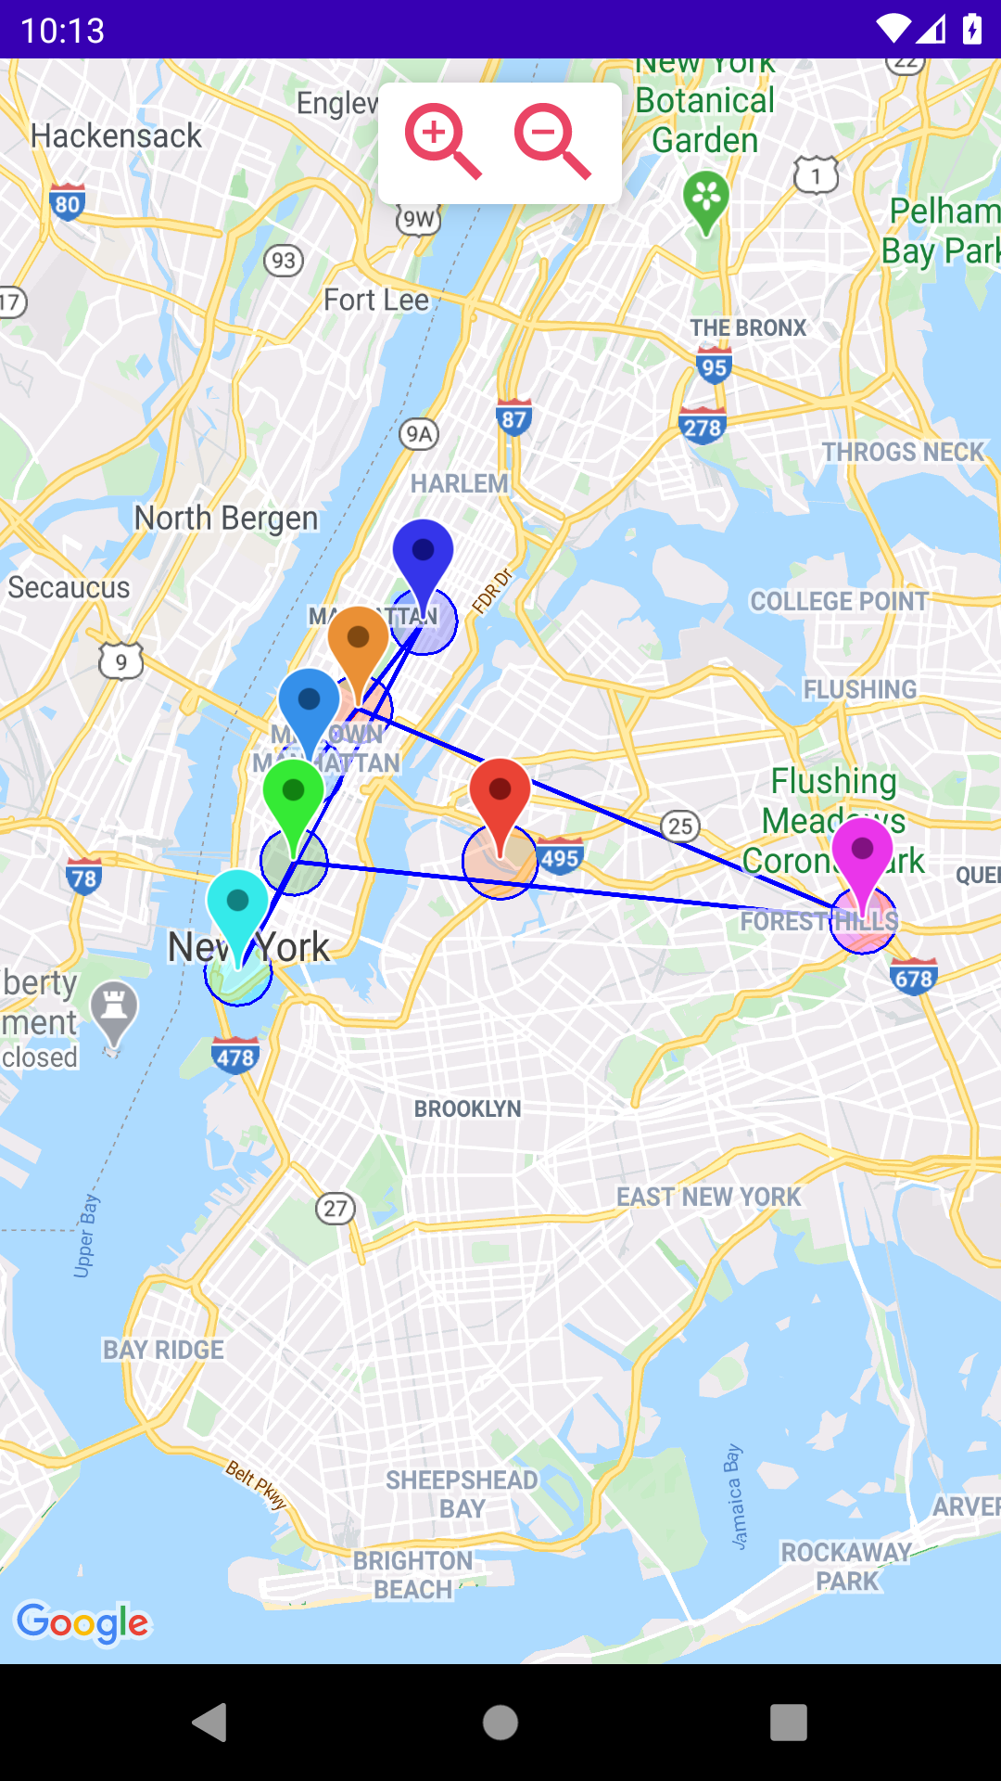

1. Show online web analyse

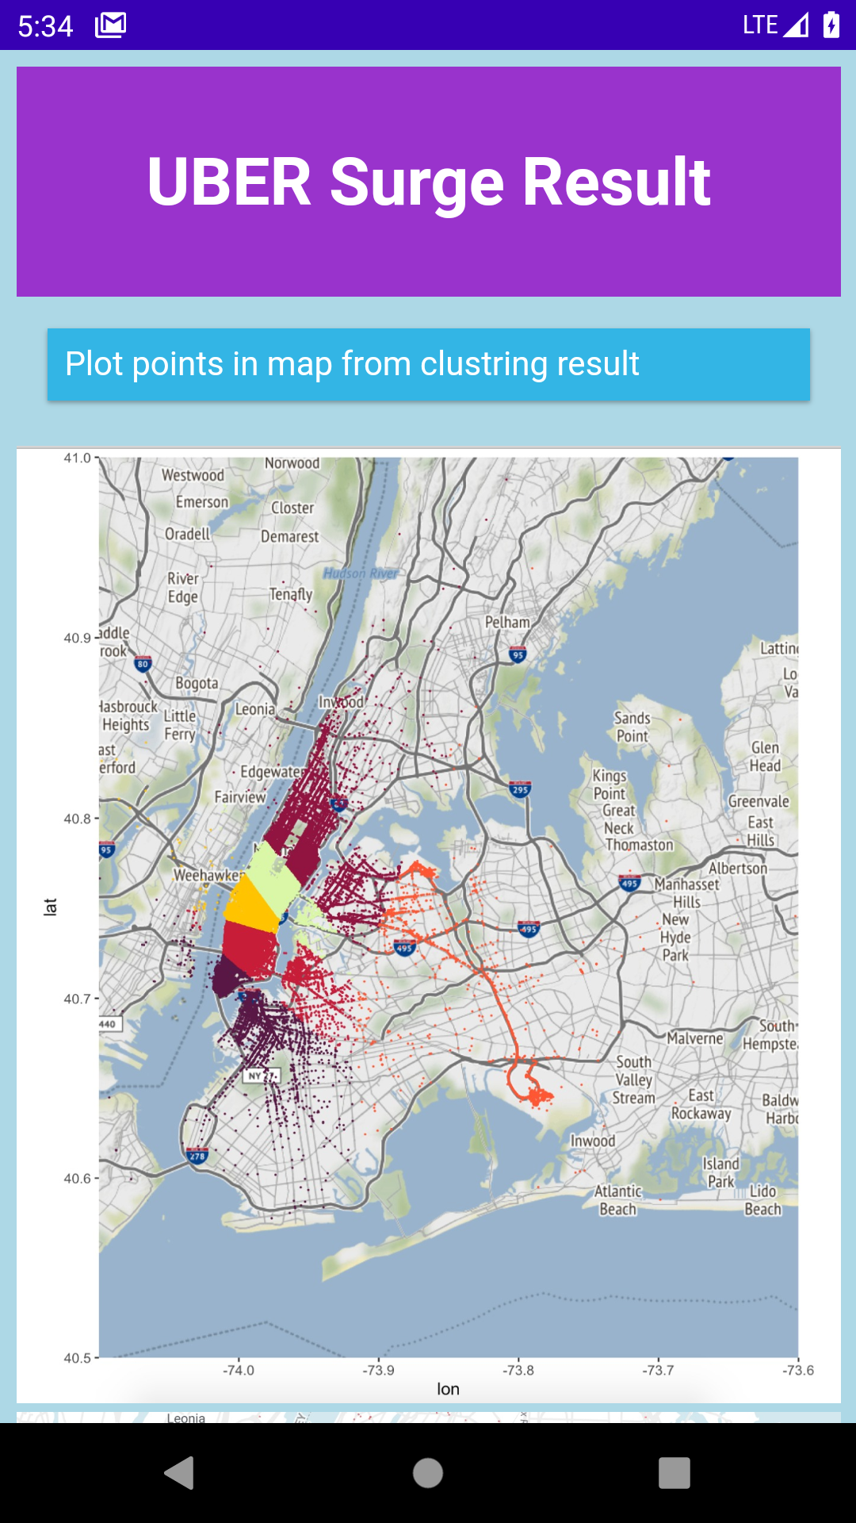

1. The map that has the searching, zooming and current location features

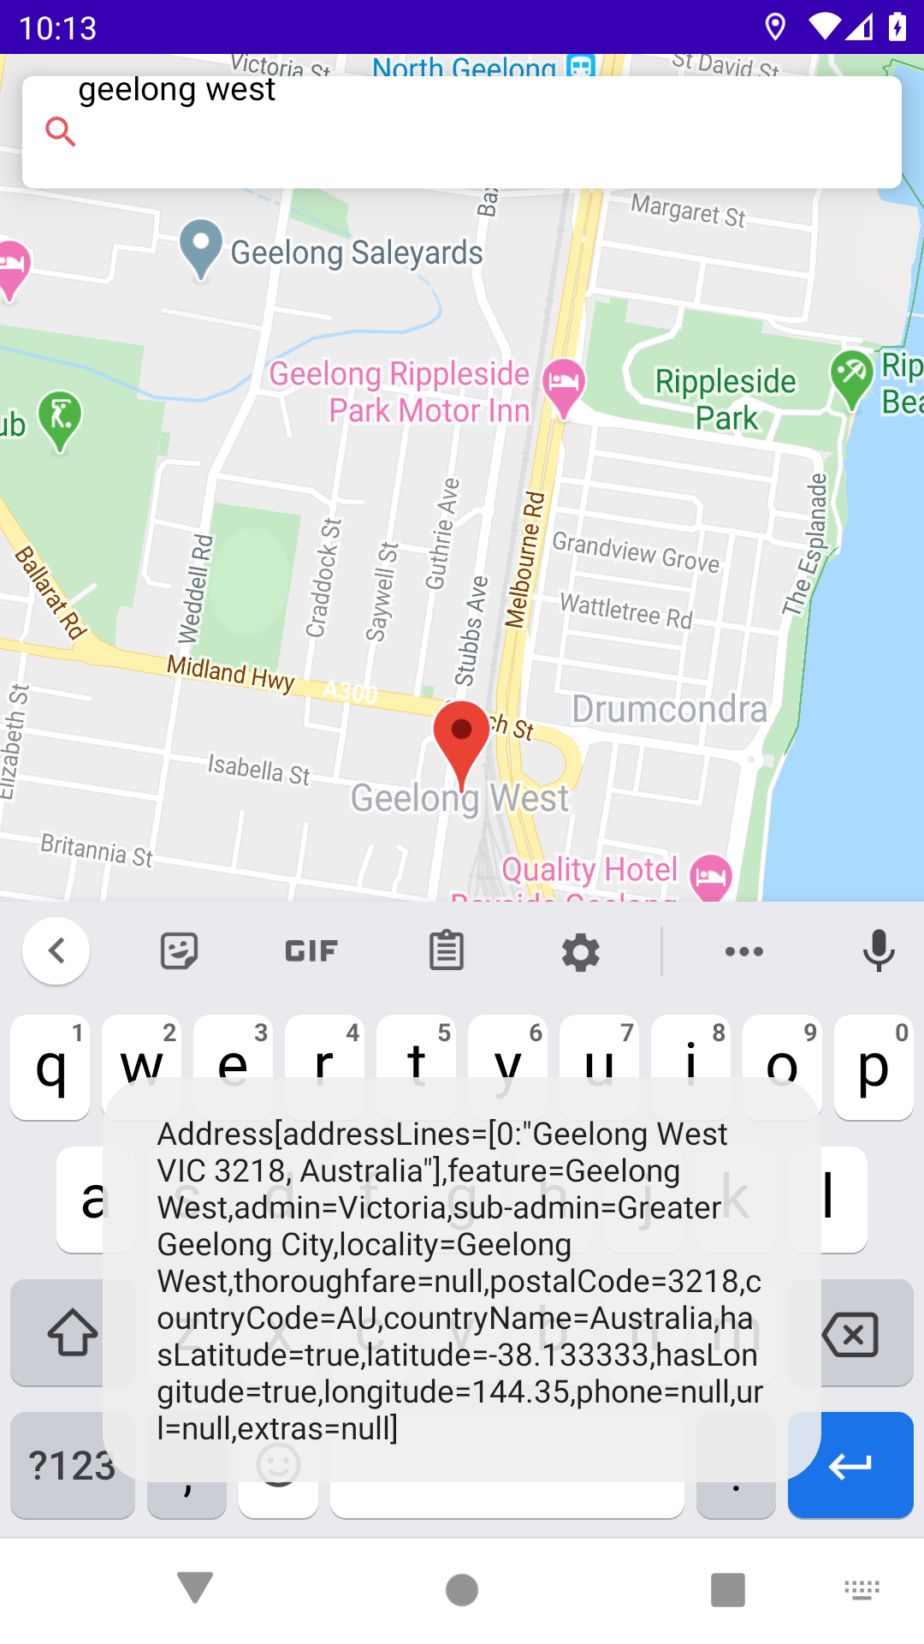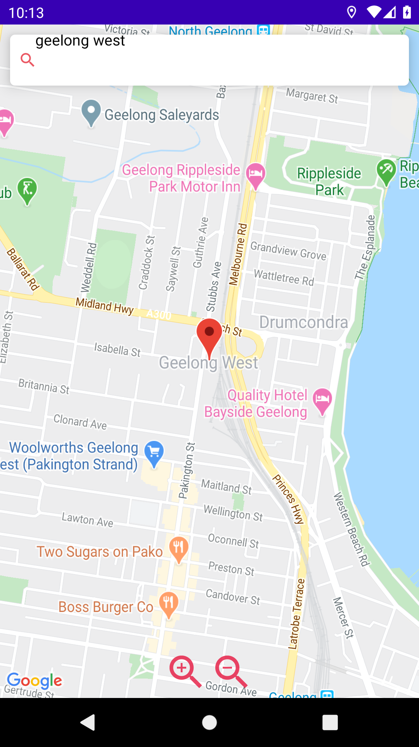

1. The charts that show two types of graph with points and the number of samples for each point

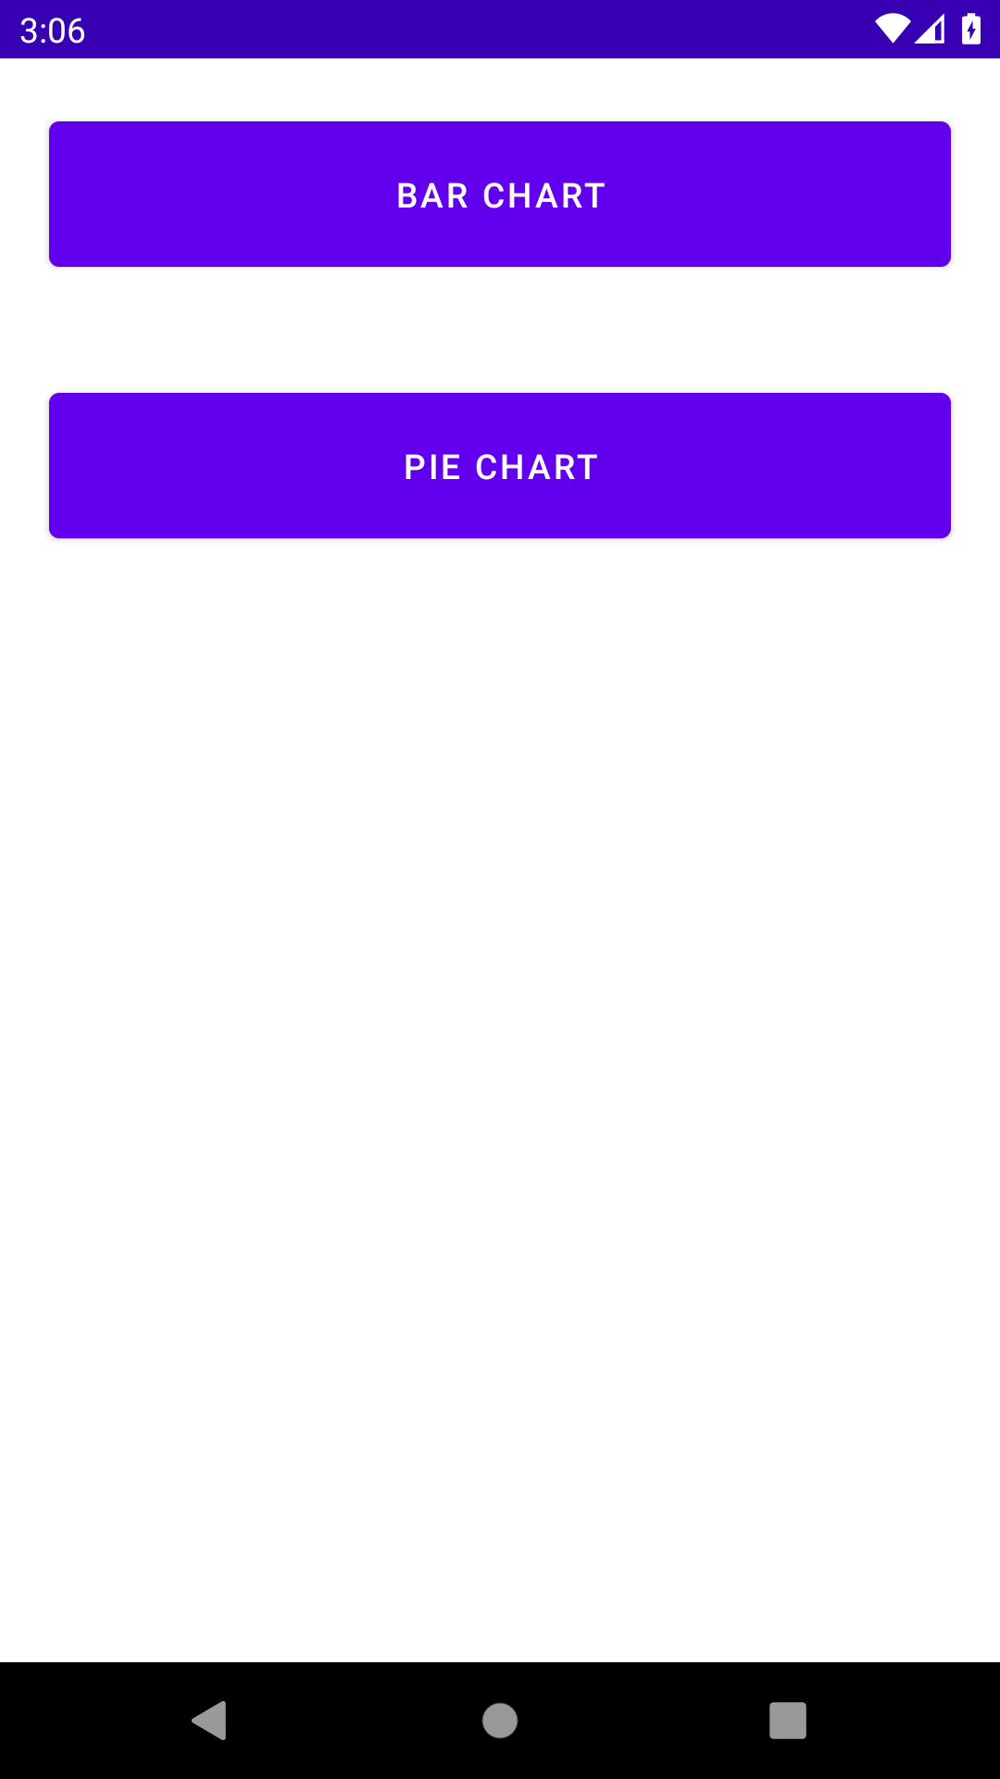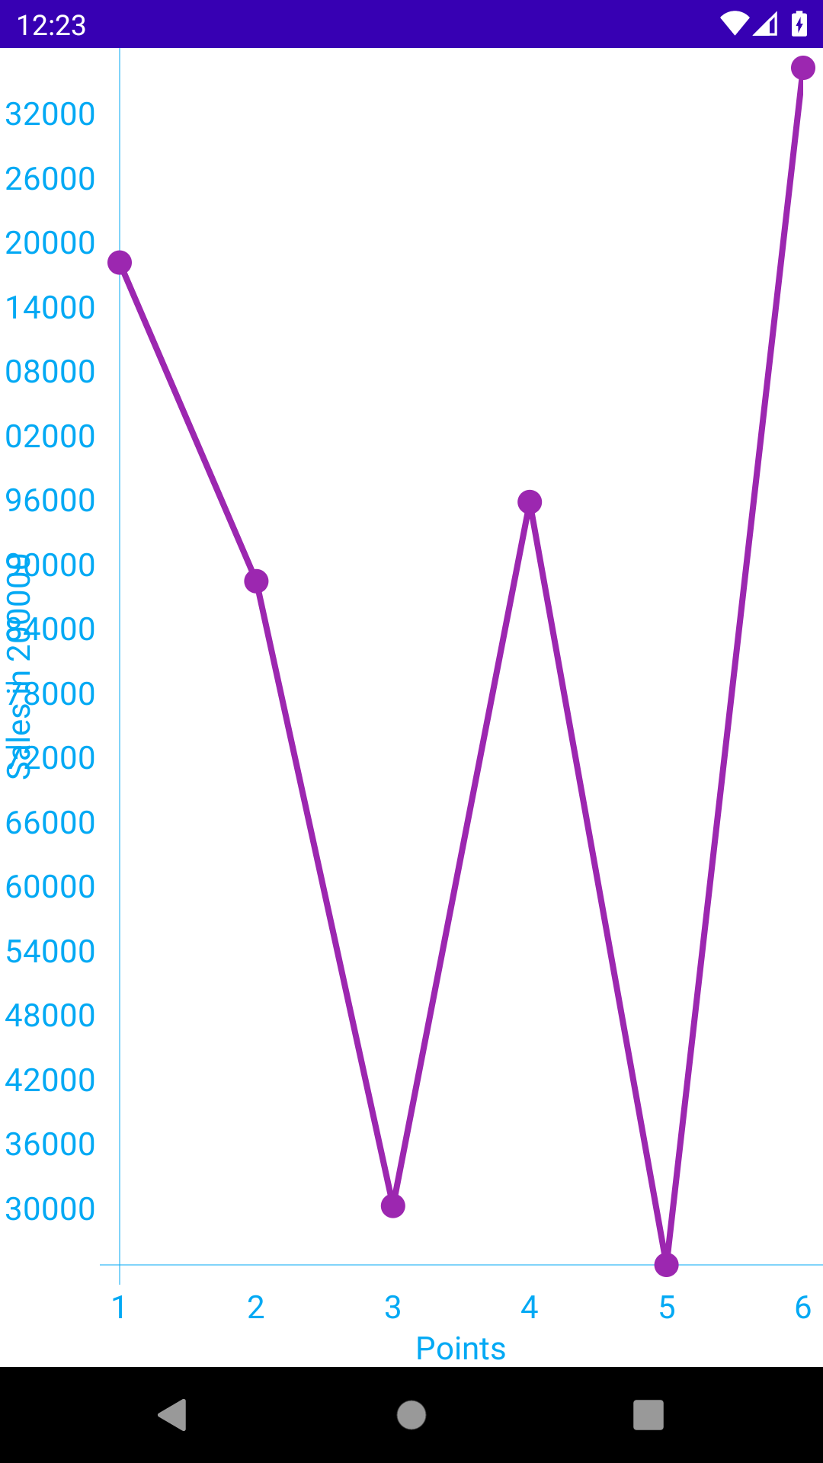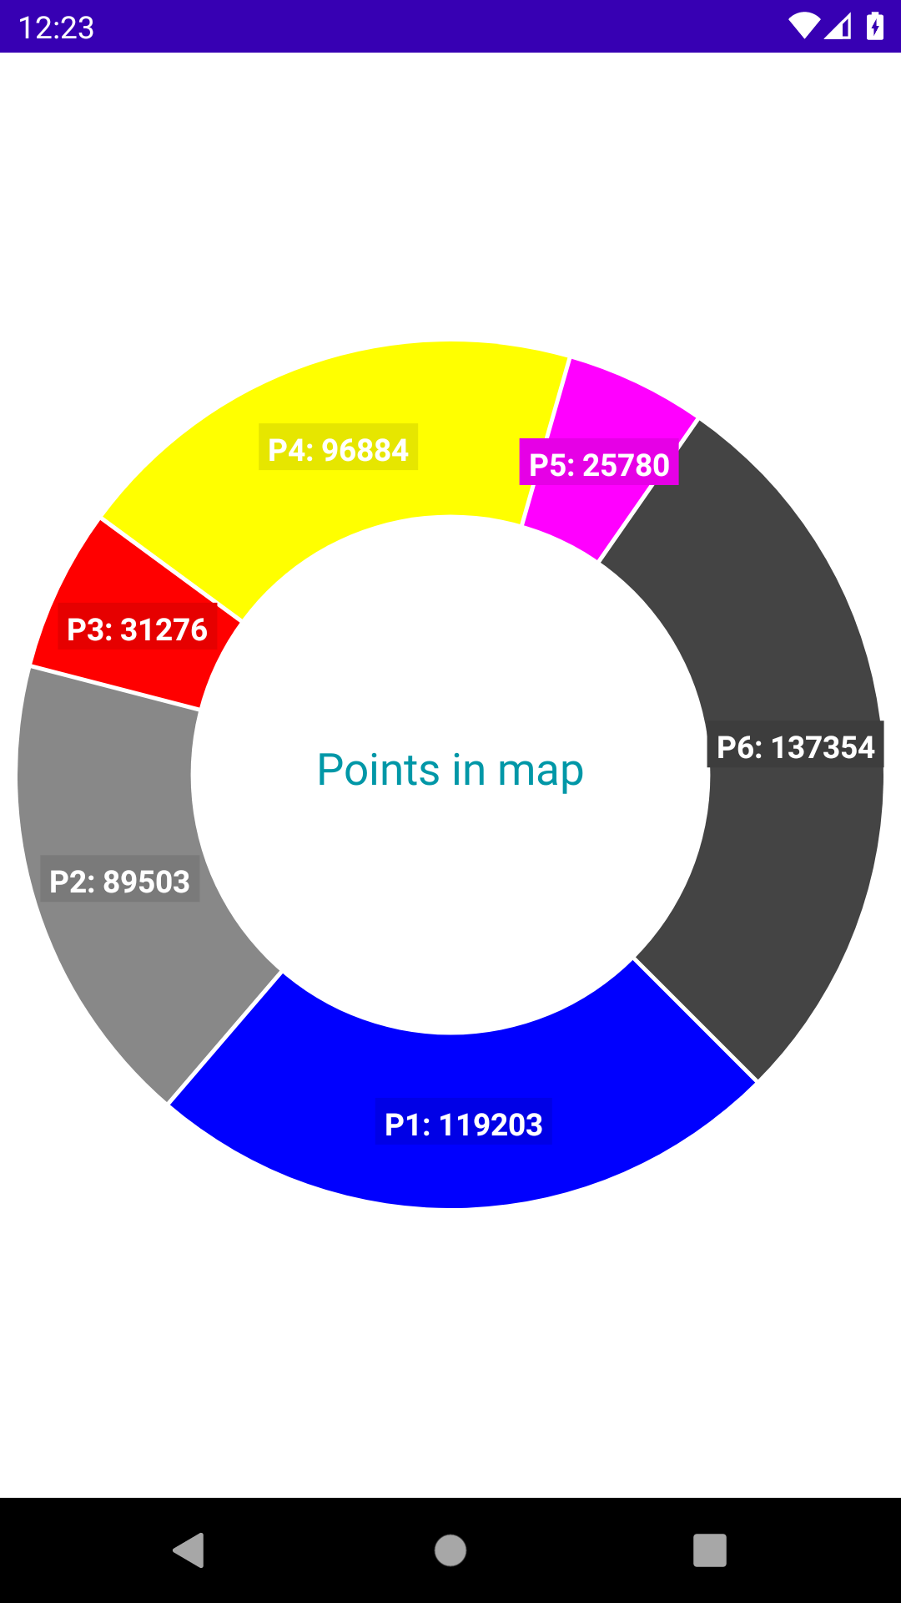

1. The notification that Cloud will send to the apps and users would be notified to check the app to see the results in the php website

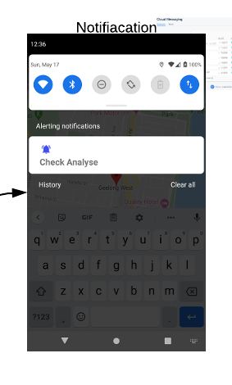

1. Application analytic results

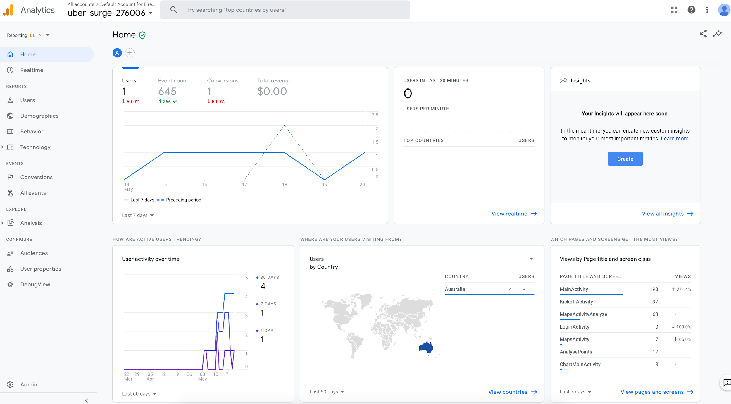

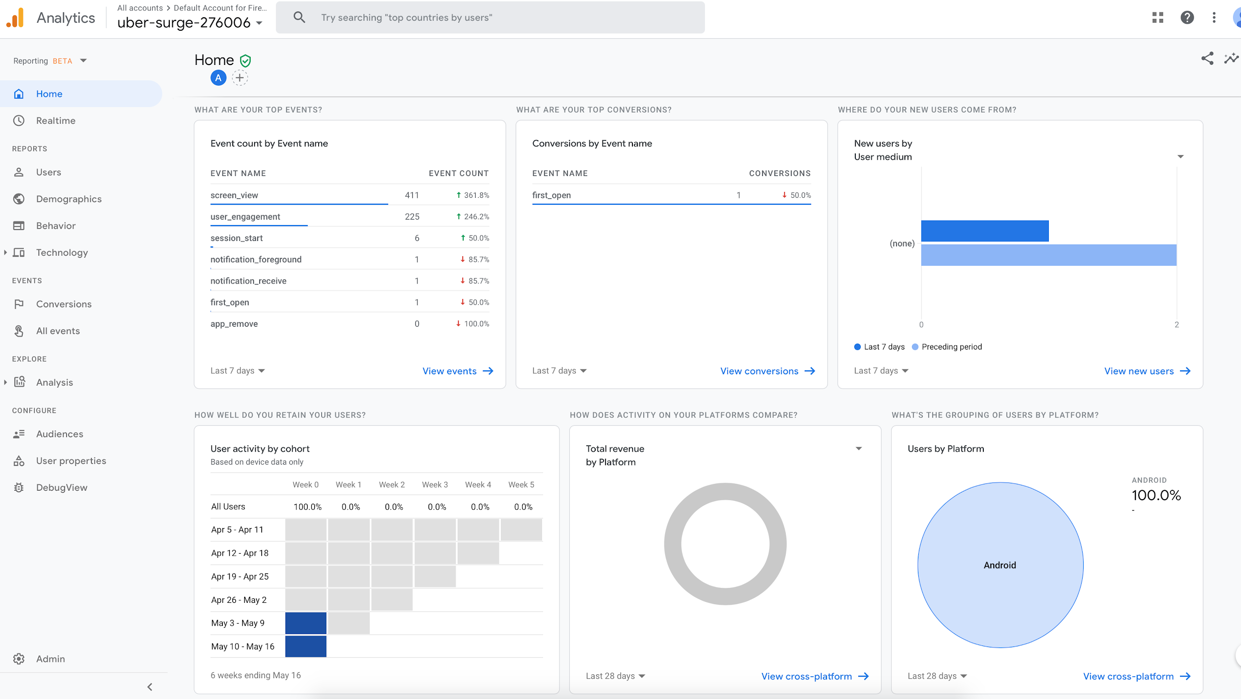

1. Running application diagram

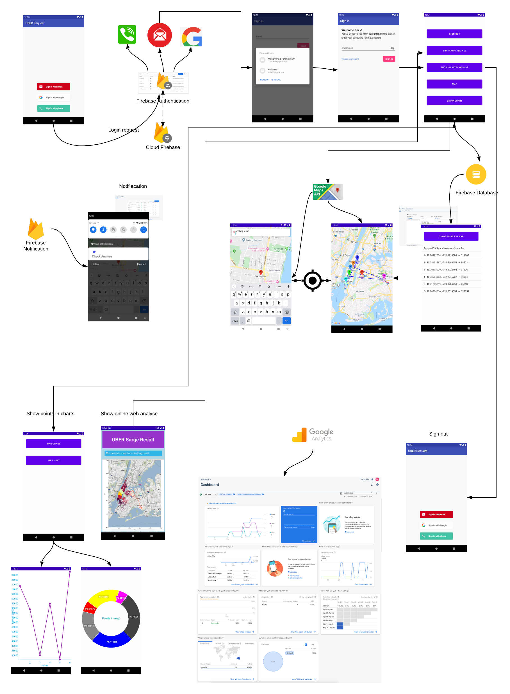

### Conclusion

So far we have developed an Android mobile app that interacts with the AWS MapReduce results on the Uber dataset and Google Cloud APIs to show the analytic results of the data. There were limitations to our work, namely the unavailability of Uber’s realtime data and high expenses and commitments for accessing the data which we left behind at this stage and used the available data instead, to have a kickstart. Our work would be a precise contribution to the police, Government, and people who need accurate analysis of the traffic flow data. Our system works perfectly with any type of data provided and results in accurate analysis.

# References

1.Traveltime.com. 2020. *3 Ways To Use Business Location Analysis*. [online] Available at: <https://traveltime.com/blog/business-location-analysis> [Accessed 17 May 2020].